Review earlier topics:

Area and perimeter.

1. Find the area and perimeter of (assume dot spacing of 1 cm)



|  |  |
| --- | --- |
| The radius of the quarter circle is 3.  Area of quarter circle is  Area of rectangle is  Area of triangle is  Total area is | The length of the arc of the quarter circle is  The length of the diagonal side is found using the Pythagorean theorem:    The horizontal side on top has length 5, and the horizontal side on the bottom has length 1.  The perimeter is |

Ratios:

2. At a dog show the ratio of mongrels to pure-breds is two to seven. If two more pure-bred dogs and two more mongrels arrive, will that ratio increase or decrease? If there are only 8 mongrels after the new dogs arrive, how many dogs are there now?

The ratio will increase, because the mongrels are less outnumbered multiplicatively, as we will see shortly:

After the new dogs arrive, there are 8 mongrels. We do not know the exact ratio, but we can figure out that before the new dogs arrived, there were 6 mongrels. At that point the ratio was 2:7, so at that time there were  pure bred dogs. After the new dogs arrive, there will be 23 pure bred dogs.

If we compare the ratios 6/21 (about 29%) and 8/23 (about 35%), we will find that 8/23 is somewhat larger. Note that it does not, however, increase to 4/9 (which is what you would get by adding 2 to each side of the simplified ratio)

3. The ratio of M&Ms to crackers in my trail mix is 1:3. I need more trail mix, so I add equal handfuls of M&Ms and crackers. Does my trail mix have a higher or lower proportion of M&Ms now? I am adding equally to a 1:3 mix, so it is getting closer to being equal amounts. That makes the proportion of M&Ms larger.

Would it be accurate to say that the new ratio of M&M’s to crackers is 2:4? Why or why not? No, we don’t have enough information to know the new ratio exactly.

Hmm... upon further consideration, I am less likely to ask a question like #3 on the exam (where there is not enough information for an exact answer) than I am to ask a question like #2 (where there is more given information)

4. Solve using a bar diagram:

a. Andrea has 2/3 as many apples as Janet. If they have 60 apples all together, how many apples does Janet have?

60 apples

|  |  |  |  |
| --- | --- | --- | --- |
| A |  |  |  |
| J |  |  |  |

= 60 ÷ 5 = 12

Janet has 3 × 12 = 36 apples.

b. The ratio of Mike’s stickers to John’s stickers is 3:5. If John has 14 more stickers than Mike, how many stickers does Mike have?

14 stickers

|  |  |  |  |  |  |
| --- | --- | --- | --- | --- | --- |
| M |  |  |  |  |  |
| J |  |  |  |  |  |

= 14 ÷ 2 = 7

Mike has 3× 7 = 21 stickers

5. Solve using rates and dimensional analysis:

Candice can make 10 teddy bears with 4 lbs of stuffing. How much stuffing will she need for 16 bears?

We know 16 bears. We need a rate of stuffing per bear.



Percents:

Solve using a grid and with algebra:

6. The price of a home rose from 120,000 to 145,000. By what percent did it increase?

grid:

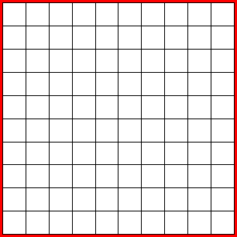 



Algebra:

145,000 is what percent of 120,000?



145,000 is 121% *of* 120,000 and is 21% *more than* 120,000

Increased by 21%

7. A video game that is on sale 35% off costs $28. What was the original price?





35% less than the original price is $28.

65% of the original price is $28



8. The price of berries was $1.40/pt in summer. In winter the price increased by 180%. What is the winter price of berries?



  



180% more than $1.40 is 280% of $1.40



Decimals:

9. Show how to multiply 1.3 × 2.7 on a grid, labelling the place-value partial products. Combine the partial products to find the total product.











Fractions:

10. Explain the meaning of the fraction 13/8, and show it on a number line.

* Split 1 unit length into 8 equal parts to find the size of 1/8



* Count and draw 13 parts of size 1/8 to get 13/8



11. Show and explain 2/3 + 4/5 using rectangular diagrams.

*Show both 2/3 and 4/5 as fractions of the chosen unit.* Split one copy of the whole unit into thirds (3 equal parts) (using horizontal lines for squares and rectangles), and shade 2 or label of them, and split another copy of the whole unit into fifths (5 equal parts) (using vertical lines) and shade or label 4 of them.

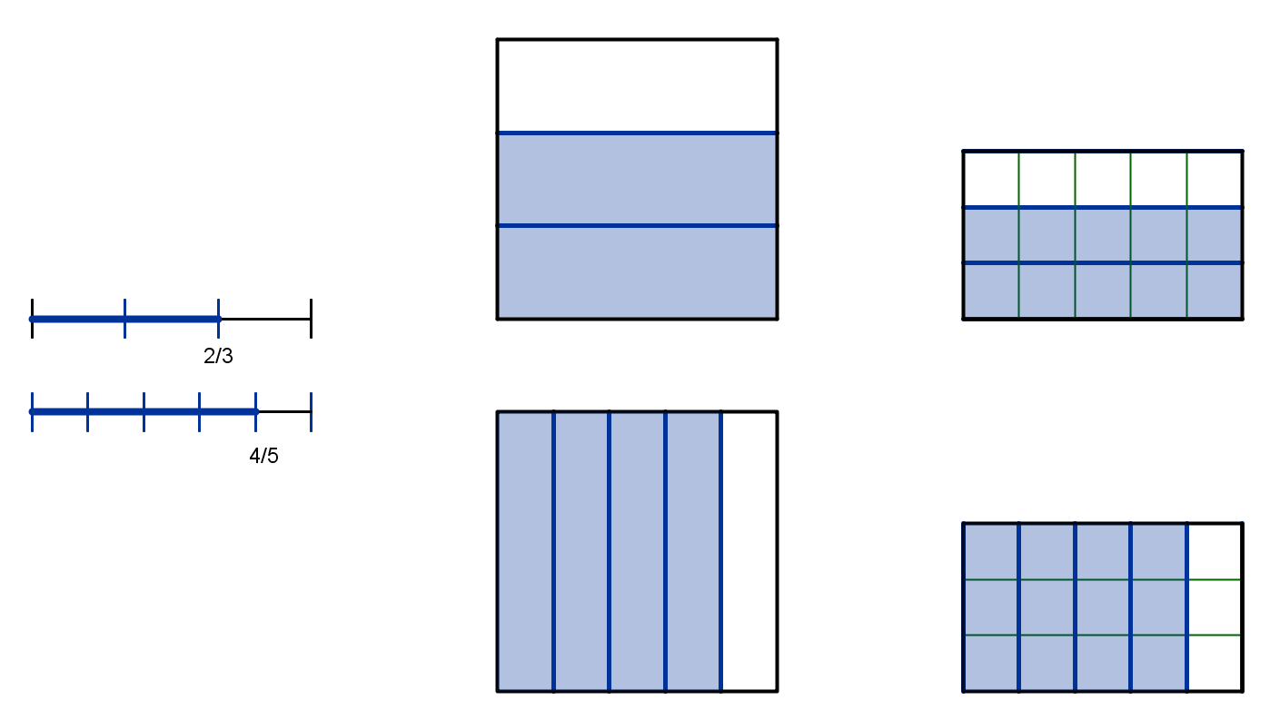

Partition each 1/3 into 5 pieces (using vertical lines), and each 1/5 into 3 equal pieces (using horizontal lines). This makes the same size of pieces in both fraction pictures.

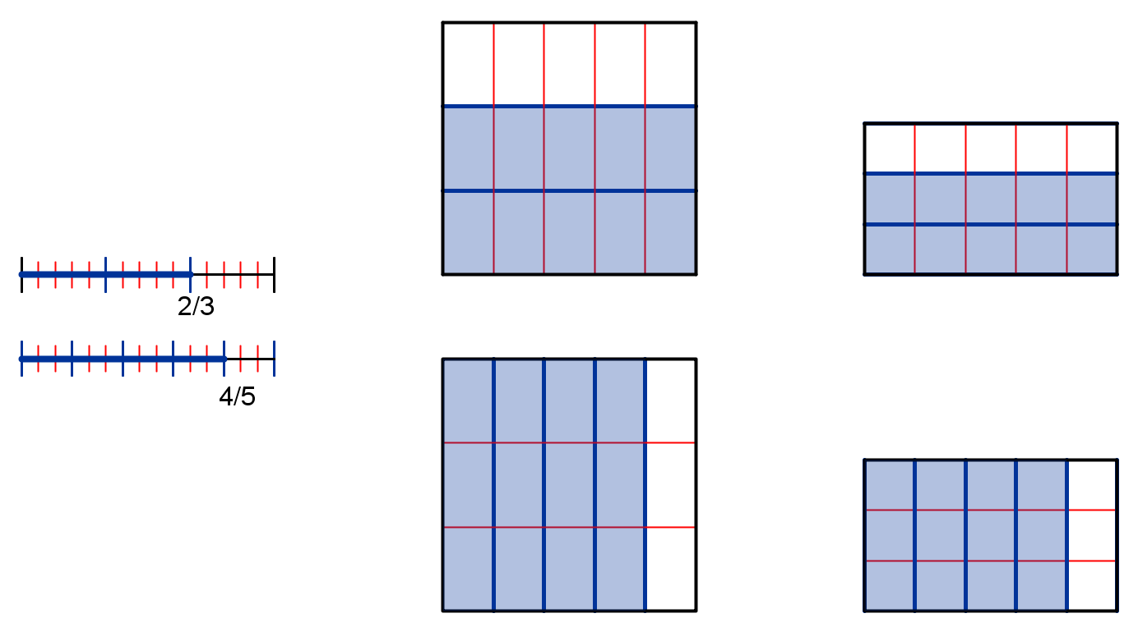

In the first diagram, each of the 2 parts in the shaded 2/3 are split into 5 parts each, so there are 2 × 5 small parts now.

Each of the 3 parts in whole in are split into 5 parts each, so there are 3× 5 small parts in a whole, and each is size 1/15.

This means 10/15 is equivalent to (is the same number/size as) 2/3: 

In the second diagram, each of the 4 parts shaded in 4/5 are split into 3 parts each, so there are 4 × 3 small parts now.

Each of the 5 parts in whole in are split into 3 parts each, so there are 5 × 3 small parts in a whole, and each is size 1/15.

This means 12/15 is equivalent to (is the same number/size as) 4/5. 

Added together, there are 10+12=22, each of which is 1/15: 

12. Show and explain 3/4 × 5/8 using a rectangular diagram.

3/4 × 5/8 means that there are sets of size 3/4 of a unit of stuff, and we want 5/8 of such a set.

3/4 × 5/8 tells how many units of stuff are in this amount

I start by showing 3/4 by partitioning a whole into 4 equal pieces and shading 3 of them.

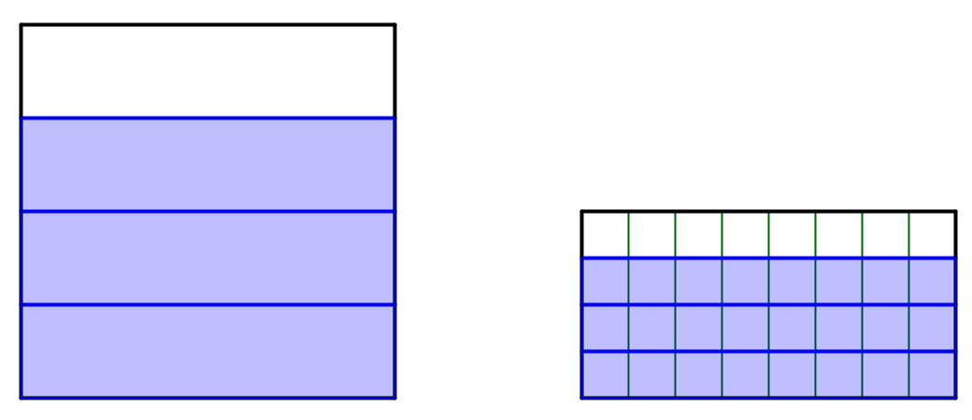

Now partition each of the fourths into 8 pieces by subdividing in the opposite direction.

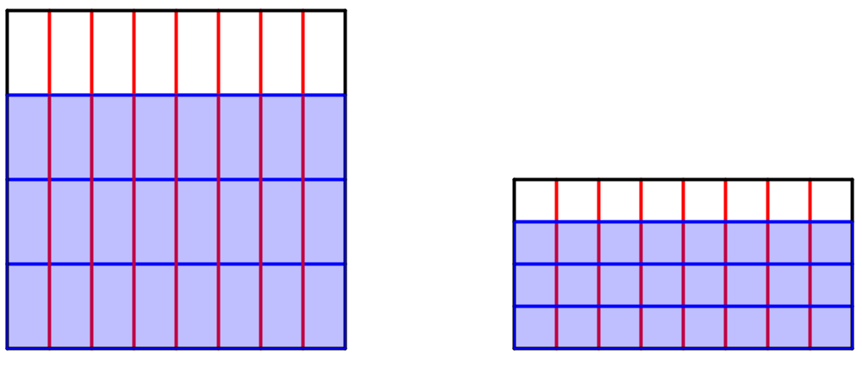

Show how much 5/8 of the 3/4 is by shading 5/8 of the part that’s shaded blue (the 3/4) in another color.

*Note: you only need to show the final picture—not all three.*

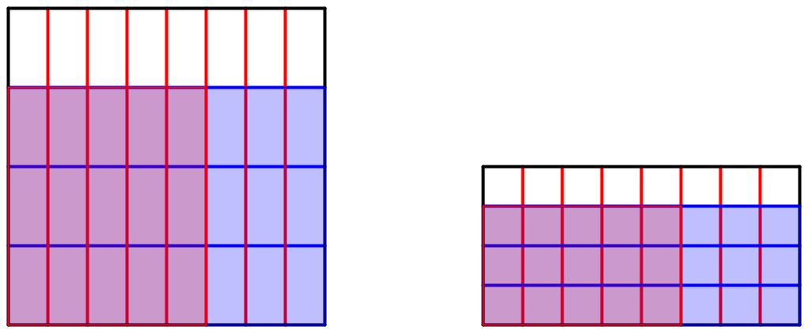

Now the whole square/rectangle that I started with was 1 unit of stuff. The blue part was 3/4 of a unit of stuff, and the red/purple is 5/8 of 3/4 of a unit of stuff. So—how many units is that?

I need to know how many boxes are in a whole unit of stuff. To partition the unit, I first made 4 parts and then I split each of those 4 into 8 parts, so a unit contains 4×8 boxes. One way to figure out how many boxes there are is to count the number of rows (4) and columns (8) in the whole unit. You can multiply rows × columns to find the total number of boxes in the whole.

I need to know how many boxes are in 5/8 of 3/4: that’s the red/purple part. I can count the number of rows (3) and the number of columns (5) and multiply those to find the number of boxes in the product:

So the product is  units.

13. Show and explain 5/6 ÷ 2/3 using a bar diagram

5/6 ÷ 2/3 means if 5/6 fills 2/3 of a set, how much fills a whole set?

So, I can draw this diagram



|  |  |  |
| --- | --- | --- |
|  |  |  |



14. Write an addition, subtraction, multiplication and division word problem with fractions

15. Solve these word problems:

a. Bob had 1/2 pan of brownies. He gave 1/3 of what he had to Mary. How much of a pan of brownies does Bob have left?

He gave 1/3 of 1/2 to Mary, so he gave her 

That means he has  of a pan left.

b. Sunflower seeds are sold in packages that weigh 3 1/4 ounces. If there is a supply of 66 ounces of sunflower seeds, how many packages of seed can be made? How many ounces of seeds will be left over?

How many parts of size 3 1/4 are in 66?

 packages

There will be 4/13 of a package =  ounce left over.

c. Alice had 3/4 lb. of candy. She gave 1/3 lb. of the candy to Scott. How much candy does she have left?

pounds – pounds:  lbs. candy.

d. Frank has 3/8 of a gallon of gas in his mower. His mower is 4/5 of the way full. How much gas would his mower hold if it were full?



 gallons of gas

e. Maureen has 3/8 of a box of marbles. A full box of marbles weighs 4/5 of a pound. How much do Maureen’s marbles weigh?

she has 3/8 of 4/5:  lb.