Base 10 materials assignment:

1. Describe a groupable (student-grouped) base 10 material. Describe one thing that being student-grouped is particularly useful for in teaching and learning.

2. Describe a pre-grouped proportional base 10 material. Describe one thing that being proportional is particularly useful for in teaching and learning.

3. Describe a non-proportional base 10 material. Describe one thing that being non-proportional is particularly useful for in teaching and learning.

4. Describe one thing that place value number cards are useful for in teaching and learning (an advantage they have over pencil and paper).

5. Look at/read about bean-sticks as a base 10 manipulative:
http://www.thecraftyclassroom.com/CECraftToolsBase10.html

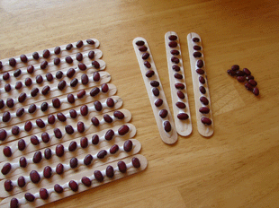

Describe this manipulative as being groupable/decomposable or not groupable/decomposable and proportional or not proportional. Explain why you categorized this manipulative as you did.

