Find the self-similarity dimension for each of these self-similar fractals. Show or explain your process:

1. This fractal that is similar to a Koch curve:



It may help to know that the rule is to delete the middle 1/2 of a length 1 segment and replace it by the equal sided trapezoid:

 

iteration 1 iteration 2

2. An unusual thing happens with this one—what is it?

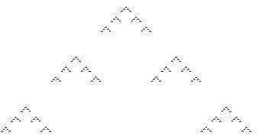

3. Note—the self-similar parts touch each other, making it a little harder to identify them!



4. And an easier one to end with!

