How To Make a Fractal questions.
http://www.naclhv.com/2014/06/how-to-make-fractal.html
This program shows you how a Mandelbrot set is made.
The Mandelbrot set is created by tracking what happens when you make repeated calculations on complex numbers.

- Start by clicking “Show me how that works” and notice that the program is doing something to find a color for each point.
- Click “How do you determine the color for a single point?”
- Watch as you have the program “Show” several iterations.
- At any point, you can have it speed up by telling it to “Do all the iterations”
- You can then start again by choosing “A new point”
- You can repeat this with some more points. Once you have figured out what is happening to each point/vector, go on to answer these questions:

Each iteration of a point consists of a rotation, dilation and translation of a point.

1. Each point that is iterated corresponds to a complex number, when the program does the rotation and dilation, what is happening to the complex number that corresponds to the rotation and dilation?

2. When the program does the translation, is it translating by the same vector for every iteration with the same starting point?

3. When you choose a new point, how is the translation vector determined?

4. When a point is completely done iterating, if you click a point on the plane, it will show you the set of iterations instantly instead of animating.
The darker circle shows a radius of 1 in the complex plane. Estimate where the following numbers should be and tell how many iterations they do before escaping:
a. 0.5+0.5i
b. -0.5+.5i
c. 0 + i
d. (r, θ) = (1, 3π/4)

5. Find a point that lies outside the darker r = 1 circle that is colored black (50 iterations without escaping). Estimate the complex number that matches the point.

6. Try out the other options (Some random points, Points in a small area, Every single point).
Look at the every single point picture. What do the bands of color tell you about the points that have that color?

- Choose to make a New fractal
- Choose a New Julia set
- Note that you’re going to choose a point to be a parameter. Write down your estimate of the polar coordinates for your parameter, or draw it here:
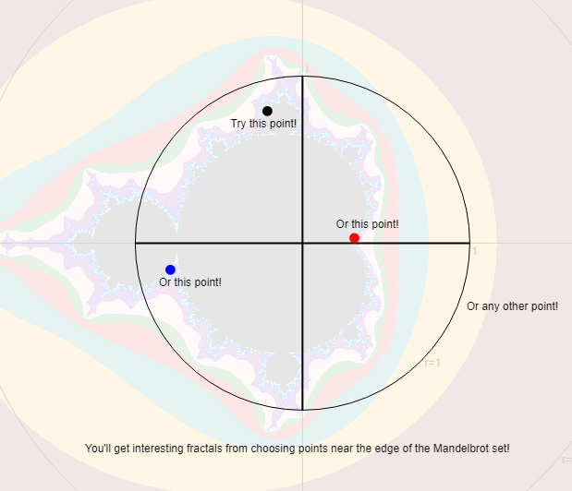

7. Choose A new point to color. (Don’t choose the same point as the red arrow that shows the parameter). Do several iterations of the point.

a. The rotation and dilation steps for this iteration are the same as for the Mandelbrot set, but the translation is different. What determines the translation vector for the iterations?

b. Choose a new point and watch an iteration or two. What is the translation vector for the iteration of this point?

c. How is this different from the Mandelbrot set iterations?

8. Make 6 Julia sets, (New fractal→New Julia Set→Pick a point→See Every single point).
For 3 of the parameter points, choose points that are colored black in the Mandelbrot set
For 3 of the parameter points, choose points that are not colored black in the Mandelbrot set.

Describe a property that is shared by the Julia sets that correspond to black points in the Mandelbrot set, that the Julia sets corresponding to the other parameters don’t have.

