Exploring/Discovering the Euler Characteristic: Build and Count
You have some snap-together squares and triangles (Polydrons). Use them to build some polyhedra.
A polyhedron is something like a 3-D polygon: it has flat sides, and its enclosed (kind of like a ball). It has faces (polygons like triangles and squares), edges (lines where two faces meet) and vertices (points where 3 or more edges meet).
You’re going to build a shape, count its faces (F), vertices (V) and edges (E) and put them in the table below. It’s easy to count wrong, so get someone else to check your work if possible.
Faces to use | Shape to make | V: number of vertices | E: number of edges | F: number of faces
6 squares | A cube
8 triangles | An octahedron  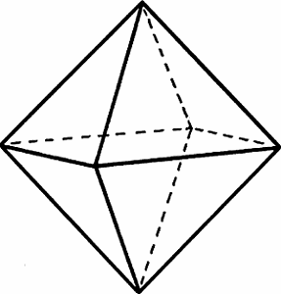
5 squares and 4 triangles | Tower:
7 squares and 2 triangles (I think I only gave you 6 squares, so do a partial build) | House:  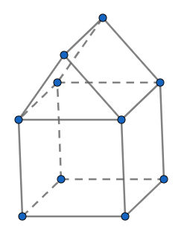

Once you have those numbers filled in, you should notice that one of the columns is consistently larger than the other two. In the final column, write the sum of the two smaller amounts (V+E, V+F or E+F).

Finally, compare the column that is (usually) largest (V, E or F) to the sum of the other two columns (V+E, V+F or E+F). Explain the relationship between the numbers in these two columns,

The Euler Characteristic of a surface is V-E+F. What is the Euler characteristic of each of the polyhedra in the table?

