Understanding the Euler Characteristic on Planar Graphs Proofs

1. Proof by construction:
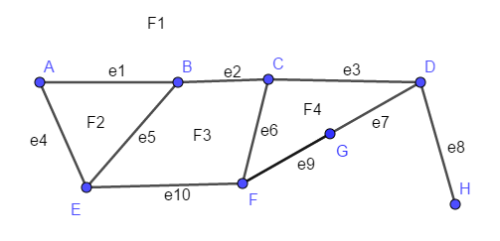
We can think about creating this graph by starting with a single vertex, and then at each step adding one of the following:
- An edge that extends to a new vertex
- A vertex that splits an edge into two edges
- An edge that connects two vertices that are already drawn (which sections off a new face)

Suppose we start with the vertex D. We can extend out from D to get the whole graph. I have filled in a few steps. Fill in the table to create the whole graph:
New vertex/ vertices | Total number of vertices | New edge(s) | Total number of edges | New Face(s) | Total number of faces | Type of Change
D | 1 |  | 0 | F1 | 1
F | 2 | Edge DF (e7) | 1 |  | 1 | I
G | 3 | e9 (e7 split into two edges | 2 |  | 1 | II
C | 4 | e3 | 3 |  | 1 | I
 | 4 | e6 | 4 | F4 | 2 | III

2. (Example) Suppose you have a planar graph with a vertices, b edges and c faces, and you add onto it an additional edge that extends to a new vertex.
a. How many vertices do you have now? a + 1
b. How many edges do you have now? b + 1
c. How many faces do you have now? c
d. Use algebra to show that the Euler Characteristic (V-E+F) doesn’t change:
Euler characteristic new = (a +1) – (b +1) + c = a +1 – b – 1 + c = a – b + c = Euler characteristic old

3. Suppose you have a planar graph with a vertices, b edges and c faces, and you add onto it a vertex that splits an edge into two edges
a. How many vertices do you have now?
b. How many edges do you have now?
c. How many faces do you have now?
d. Use algebra to show that the Euler Characteristic (V-E+F) doesn’t change:

4. Suppose you have a planar graph with a vertices, b edges and c faces, and you add onto it an additional edge that connects two already existing vertices.
a. How many vertices do you have now?
b. How many edges do you have now?
c. How many faces do you have now?
d. Use algebra to show that the Euler Characteristic (V-E+F) doesn’t change:

5. Example For our graph from #1, the subgraph consisting of all of the vertices (A, B, C, D, E, F, G, H) and edges: e1, e2, e3, e8, e4, e10, e9 is a spanning tree. It has 8 vertices and 7 edges (1 more vertex than edge)
The dual of this in the dual graph consists of all of the faces (F1, F2, F3, F4) and the edges e5, e6, e7 is a spanning tree in the dual graph. It has 4 faces and 3 edges (one more face than edge)

6. For this graph:
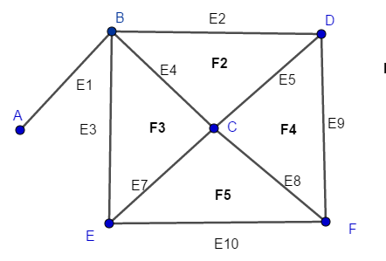
a. Write down a spanning tree:
Vertices:

Edges:

b. How many vertices and edges does the spanning tree have?
Vertices:
Edges:

c. Write down the dual of the spanning tree in the dual graph:
Faces:

Edges:

d. How many vertices and edges does the dual tree have?
Faces:
Edges:

7. Using the spanning tree reasoning, if V is the number of vertices, then the number of edges in the spanning tree is V-1.
If F is the number of faces, what is the number of edges in the dual of the spanning tree?
Fill in the blank: then the total number of edges is (V-1) +
Fill in the blanks and simplify V – E + F = V – ( (V - 1) + ( ) ) + F =

