# Tens Go Fish! (Grades 1-3, Addition to 10)

Number of players: Two to four



**5**

**3**

**7**

**2**

**9**

What you need:

* A regular deck of cards with kings, jacks, and jokers removed, with the aces used for the number 1 and queens used for the number 0, or a set of number cards with numbers 0-10 (or 1-9)

How to play:

1. Five cards are dealt to each player. The remaining cards are put face down in the middle as the draw stack.
2. Each player puts down any pair of cards that adds up to 10 as a “book.” For example, if a player had a queen (0), 2, 3, 5, and 7 cards, the player would put down the 3 and the 7 to make a book.
3. On his or her turn, each player asks one other player for a card that adds up to 10, when added to another card in the first player’s hand. For example, if a player had a queen (0), 2, and 5 cards, the player might ask another player for a 10, 8, or 5 card.

* If the other player ***does have*** the card, he or she gives it to the first player (the other player only gives one card, even if they have two of the number asked for). The first player puts down the resulting book. Play then proceeds to the next player. (For this version of Go Fish!, the player doesn’t get to keep asking if he or she gets the card that was asked for.)
* If the player ***doesn’t have*** the card, the player says “Go fish!” The first player then draws a card from the draw stack. If the new card makes a book with a card that’s already in the player’s hand, the player can put down the book at that time.

1. If a player runs out of cards, he or she takes the top card from the draw stack.
2. Play continues until all of the cards in the draw stack have been drawn and all possible plays have been made. The player with the largest number of completed books wins.

**Example:** Cards that add up to 10

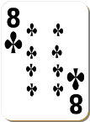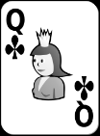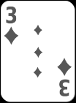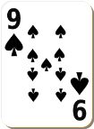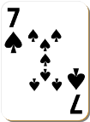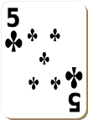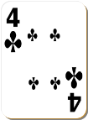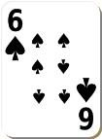

Variation: Choose a number below 10 as the “target” number, then go through the deck and discard all cards that are higher than the target number. Play the game as described above, combining pairs of cards to reach the target number to make books.