Pizza Delivery (Grades 3-6, Comparison with Addition, Multiplication and Fractions)
Number of players: Two to four
What you need:
- One 6-sided die
- Pizza Cards (cut out and shuffled) (see pp. 42-43)
- Delivery Order Cards (cut out, shuffled, and face down in a stack) (see p. 44)
How to play:
- Each player is dealt 6 Pizza Cards. The rest are not used as part of the game.
- Players take turns turning over a Delivery Order Card and rolling a die to make a Delivery Order (the number on the die goes in the empty box on the Delivery Order Card). If the Delivery Order Card has a fraction, the player must reroll if he/she gets a 1.
- If the player has a Pizza Card that matches the order, he/she sets that card aside into a pile of “delivered Pizzas.”
- If the player doesn’t have a Pizza Card that matches the order, the next player in the circle tries to match the order. This continues until the order is filled or all the players have tried to fill the order.
- After the order is filled (or all the players have tried and failed to fill the order), the Delivery Order Card is returned to the bottom of the stack.
- The first player to deliver all of his/her pizzas (play all the Pizza Cards) wins.

Variations: For younger children (grades 1-2), pull out the Delivery Order Cards with fractions. For a faster game, you can end when a player has only one pizza remaining (the first to deliver 5 pizzas wins).
Examples

 | A player rolls a 4 and turns over this card:  Delivery Order  A pizza with fewer  green peppers than mushrooms. |  | A player rolls a 3 and turns over this card:  Delivery Order  of the pizza slices have olives. (Reroll 1’s)  1 |  | A player rolls a 4 and turns over this card:  Delivery Order  A pizza with as many olives as pepperoni.
The complete delivery order is: A pizza with 4 fewer green peppers than mushrooms.  This pizza fills the order because 6 is 4 less than 10  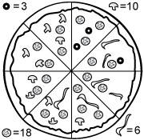  . |  | The complete delivery order is: 1/3 of the pizza slices have olives.  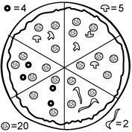  This pizza fills the order because olives are shown on 2 slices, and 2 slices is 1/3 of 6 total slices. |  | 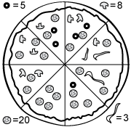  The complete delivery order is: A pizza with 1/4 as many olives as pepperoni.  This pizza fills the order because 5 is 1/4 of 20.

Pizza Cards
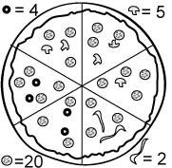 | 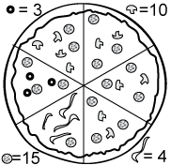 | 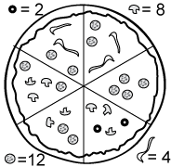
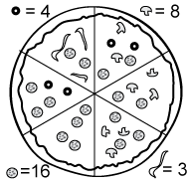 | 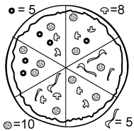 | 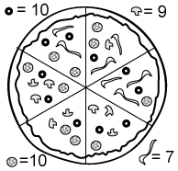
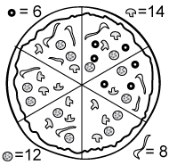 | 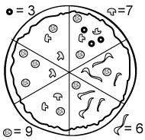 | 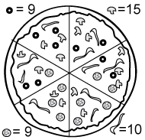
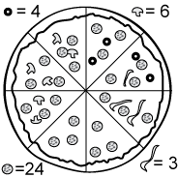 | 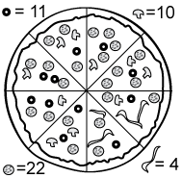 | 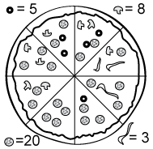

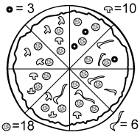 | 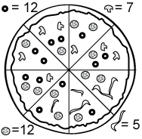 | 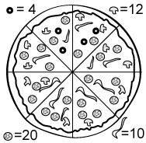
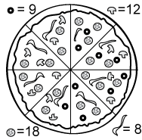 | 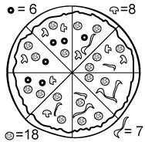 | 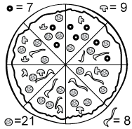
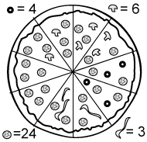 | 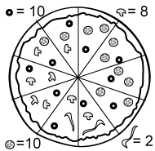 | 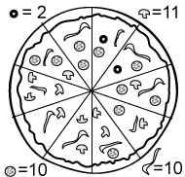
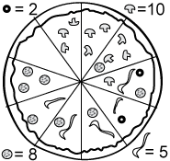 | 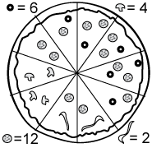 | 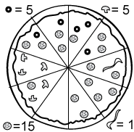
olives: pepperoni: mushrooms: green peppers:

Delivery Order Cards
Delivery Order  A pizza with more mushrooms than green peppers. | Delivery Order  A pizza with more mushrooms than green peppers. | Delivery Order  A pizza with fewer green peppers than mushrooms.
Delivery Order  A pizza with fewer green peppers than mushrooms. | Delivery Order  A pizza with times as many pepperoni as olives. | Delivery Order  A pizza with times as many pepperoni as olives.
Delivery Order  A pizza with as  1  many olives  as pepperoni.  (Reroll 1’s) | Delivery Order  A pizza with as  1  many olives  as pepperoni.  (Reroll 1’s) | Delivery Order  The number of mushrooms on the pizza is a multiple  of .
Delivery Order  of the pizza slices have olives. (Reroll 1’s)  1 | Delivery Order  of the pizza slices have green peppers. (Reroll 1’s)  1 | Delivery Order  A pizza that people can share evenly.

