Math Bingo
This game has several different versions, depending on the specific skills that are being taught.

Addition Bingo (Grades K-1, Addition)
Number of players: Two or more
What you need:
- Two 6-sided dice
- A copy of the Math Bingo Game Board (p. 27) for each player
- A pen or pencil per player
- 21 counters per player
How to play:
- Each player makes his or her game board by writing a number between 2 and 12 inside each square on his or her copy of the Math Bingo Game Board (except the free space). The player gets to choose which number goes inside each square. Make sure that each player’s game board is different. (It’s OK to use the same number more than once.)
- Players take turns rolling the dice and adding the numbers together.
- The player says the addition sentence that goes with the dice he/she rolled. For example, if the player rolled a 1 and a 6, he/she would say, “One plus six is seven.”
- Each player who has an open square with the answer from Step (a) puts a counter on that square. If the game board has more than one square with that number, the player gets to choose which square is covered.
- The first player to cover 5 squares in a row (vertical, horizontal, or diagonal) wins.
Note on strategy: The strategy in this game comes in the numbers that a player chooses to put on his or her game board and the choices the player makes about which square to cover. For example, there’s a higher chance of getting a 7 than a 2. However, if you make a game board with nothing but 7’s, it will probably take longer to get a Bingo than if you make a game board with a wider range of numbers!
Example

2 | 4 | 5 | 6 | 6
9 | 7 | 10 | 8 | 11
7 | 8 | FREE | 6 | 4
4 | 9 | 8 | 3 | 5  + = 7
3 | 6 | 7 | 12 | 7

Advanced Addition Bingo (Grades 1-3, Addition)
This game is the same as Addition Bingo, except that it uses two 10-sided dice and includes a wider range of numbers.
Number of players: Two or more
What you need:
- Two 10-sided dice.
- A copy of the Math Bingo Game Board (p. 27) for each player
- A pen or pencil per player
- 21 counters per player
How to play:
- Each player makes his or her game board by writing a number between 2 and 20 inside each square on his or her copy of the Math Bingo Game Board (except the free space). The player gets to choose which number goes inside each square. Make sure that each player’s game board is different. (It’s OK to use the same number more than once.)
- Players take turns rolling the dice and adding the numbers together, using the 0 for a 10.
- The player says the addition sentence that goes with the dice he/she rolled. For example, if the player rolled a 0 and a 2, he/she would say, “Ten plus two is twelve.”
- Each player who has an open square with the answer from Step (a) puts a counter on that square. If the game board has more than one square with that number, the player gets to choose which square is covered.
- The first player to cover 5 squares in a row (vertical, horizontal, or diagonal) wins.
Note on strategy: The strategy in this game comes in the numbers that a player chooses to put on his or her game board and the choices the player makes about which square to cover. For example, there’s a higher chance of getting a 10 than a 2. However, if you make a game board with nothing but 10’s, it will probably take longer to get a Bingo than if you make a game board with a wider range of numbers.
Example

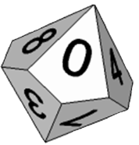
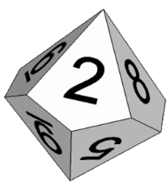
3 | 14 | 5 | 18 | 6
9 | 7 | 10 | 8 | 11
13 | 11 | FREE | 20 | 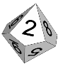  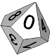  16  1 + = 12
4 | 9 | 8 | 11 | 5
17 | 15 | 2 | 12 | 10

Subtraction Bingo 0–9 (Grades 1-3, Subtraction)
Number of players: Two or more
What you need:
- Two 10-sided dice
- A copy of the Math Bingo Game Board (p. 27) for each player
- A pen or pencil per player
- 21 counters per player
How to play:
- Each player makes his or her game board by writing a number between 0 and 9 inside each square on his or her copy of the Math Bingo Game Board (except the free space). The player gets to choose which number goes inside each square. Make sure that each player’s game board is different. (It’s OK to use the same number more than once.)
- Players take turns rolling the dice. After the dice are rolled, the player subtracts the smaller number from the larger number.
- The player says the subtraction sentence that goes with the dice he/she rolled. For example, if the player rolled an 8 and a 5, he/she would say, “Eight minus five is three.”
- Each player who has an open square with the answer from Step (a) puts a counter on that square. If the game board has more than one square with that number, the player gets to choose which square is covered.
- The first player to cover 5 squares in a row (vertical, horizontal, or diagonal) wins.

Example

3 | 8 | 5 | 2 | 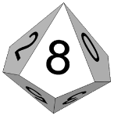  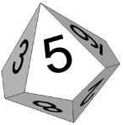  6
2 | 7 | 0 | 8 | 1
0 | 4 | FREE | 1 | 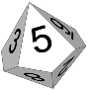  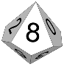  3  - = 3
4 | 2 | 9 | 3 | 5
1 | 6 | 2 | 4 | 0

Subtraction Bingo, Teen Version (Grades 2-3, Subtraction)
Number of players: Two or more
What you need:
- One 10-sided die
- A copy of the Math Bingo Game Board (p. 27) for each player
- A pen or pencil per player
- 21 counters per player
How to play:
- Each player makes his or her game board by writing a number between 1 and 19 inside each square on his or her copy of the Math Bingo Game Board (except the free space). The player gets to choose which number goes inside each square. Make sure that each player’s game board is different. (It’s OK to use the same number more than once.)
- Players take turns rolling the die and doing the subtraction:
- The player rolls the die once and adds a ten to that number. For example, if the player rolled a 6, the result would be 16.
- The player rolls the die again and subtracts its value. For example, if the player rolled a 4, the result would be 12, since 16 – 4 = 12.
- The player says the subtraction sentence: for example, “Sixteen minus four is twelve.”
- Each player who has an open square with the answer from Step (c) puts a counter on that square. If the game board has more than one square with that number, the player gets to choose which square is covered.
- The first player to cover 5 squares in a row (vertical, horizontal, or diagonal) wins.

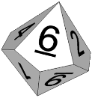
Example

9 | 8 | 1 | 17 | 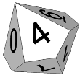  10  First roll:
2 | 7 | 10 | 8 | 18  Second roll:
19 | 16 | FREE | 13 | 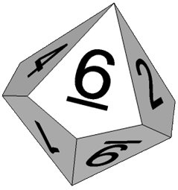  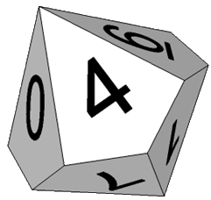  3  1 - = 12
4 | 14 | 9 | 3 | 5
11 | 6 | 15 | 10 | 12

Multiplication Bingo (Grades 4-6, Multiplication)
Number of players: Two or more
What you need:
- Two 10-sided dice
× | 1 | 2 | 3 | 4 | 5 | 6 | 7 | 8 | 9 | 10
1 | 1 | 2 | 3 | 4 | 5 | 6 | 7 | 8 | 9 | 10
2 | 2 | 4 | 6 | 8 | 10 | 12 | 14 | 16 | 8 | 20
3 | 3 | 6 | 9 | 12 | 15 | 18 | 21 | 24 | 27 | 30
4 | 4 | 8 | 12 | 16 | 20 | 24 | 28 | 32 | 36 | 40
5 | 5 | 10 | 15 | 20 | 25 | 30 | 35 | 40 | 45 | 50
6 | 6 | 12 | 18 | 24 | 30 | 36 | 42 | 48 | 54 | 60
7 | 7 | 14 | 21 | 28 | 35 | 42 | 49 | 56 | 63 | 70
8 | 8 | 16 | 24 | 32 | 40 | 48 | 56 | 64 | 72 | 80
9 | 9 | 8 | 27 | 36 | 45 | 54 | 63 | 72 | 81 | 90
10 | 10 | 20 | 30 | 40 | 50 | 60 | 70 | 80 | 90 | 100

Multiplication Table
- A copy of the Math Bingo Game Board (p. 27) for each player
- 21 counters per player
- A piece of paper and pen or pencil per player
How to play:
- Each player makes his or her game board by writing a number from the multiplication table (up to 10 × 10) inside each square on his or her copy of the Math Bingo Game Board (except the free space). The player gets to choose which number goes inside each square. Make sure that each player’s game board is different. (It’s OK to use the same number more than once.)
- Players take turns rolling the dice and multiplying the numbers together, using the 0 for a 10.
- The player says the multiplication sentence that goes with the dice he/she rolled. For example, if the player rolled a 2 and a 6, he/she would say, “Two times six is twelve.”
- Each player who has an open square with the answer from Step (a) puts a counter on that square. If the game board has more than one square with that number, the player gets to choose which square is covered.
- The first player to cover 5 squares in a row (vertical, horizontal, or diagonal) wins.
Example

12 | 8 | 3 | 40 | 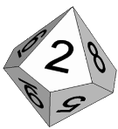  1
42 | 72 | 80 | 8 | 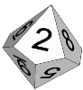  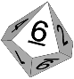  24  x = 12
20 | 28 | FREE | 9 | 18
4 | 14 | 32 | 45 | 12
60 | 90 | 15 | 10 | 63

Math Bingo Game Board

FREE

