# Close to 20 (Grades 1-3, Addition of Numbers Up to 10, Subtraction of Numbers from 20)

Number of players: Two or more

What you need:

* A regular deck of cards with face cards (kings, queens, jacks, jokers) removed, and with the aces used for the number 1
* Piece of paper and pencil/pen for each player to keep score

How to play: During each round:

( + + ) – 20 = 2

**Example**

1. Five cards are dealt to each player.

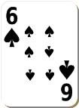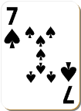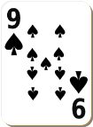

1. Each player chooses three cards that add up as close as possible to 20 and discards the other two cards.
2. Each player adds up the three cards.

* For example, if the player had kept a 3, a 5, and a 7, the result would be 15.

1. Each player compares his/her results to the number 20 and subtracts the smaller number from the larger number to find the difference. This difference is the player’s score for that round.

* For example, if one player’s cards added up to 15, that number would be subtracted from 20, resulting in a score of 5. If the other player’s cards added up to 22, then 20 would be subtracted from that number, resulting in a score of 2.

1. Each player adds the score to his or her total from earlier rounds.

Play continues for five rounds. The player with the *lowest* total wins.