## Pig (sometimes called Skunk) (Grades 1-4, Addition)

Number of players: Two or more

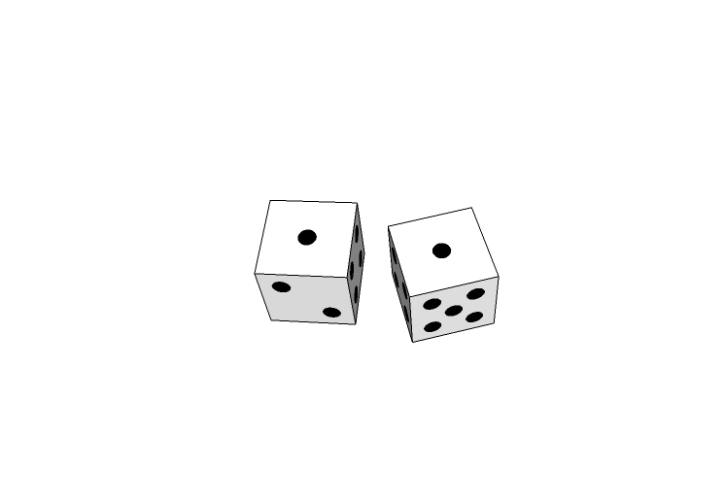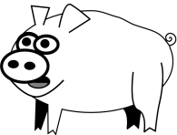

What you need:

* Two 6-sided dice
* Piece of paper and pencil/pen for each player to keep score

How to play: Players take turns rolling the dice. Each round, they add the numbers mentally, then add the score to their total from earlier rounds. The first player to reach 100 wins. But there are a couple of twists:

* If you roll a 1 on one die, your score for that round is zero.
* If you roll 1’s on both dice, it reduces your total to zero and you have to start over.

## Massachusetts Outline Clip ArtGoing to Boston (Grades 1-4, Addition)

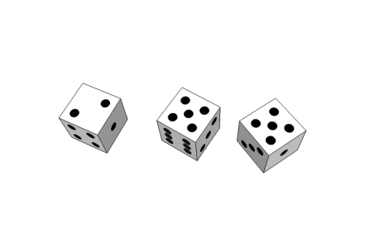Number of players: Two or more

What you need:

* Three 6-sided dice
* Piece of paper and pencil/pen for each player to keep score

How to play: Players take turns rolling the dice. Each player’s turn goes like this:

1. A player rolls all three dice.
2. The player sets aside the highest die, then rerolls the two lower dice.
3. The player sets aside the higher of the two dice he just rerolled, then rerolls the lowest die.
4. The player adds up the three dice mentally, then adds the score to his or her total from earlier rounds.

The first player to reach 100 wins.

## Triples (Grades 1-4, Addition)

**Example**

12 + 5 = 17

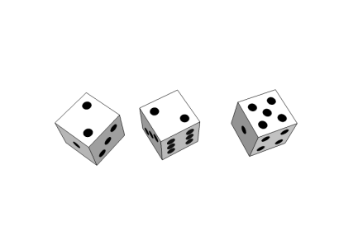Number of players: Two or more

What you need:

* Three 6-sided dice
* Piece of paper and pencil/pen for each player to keep score

How to play: Players take turns rolling all three dice. If desired, the player can choose to reroll one die. Scoring goes like this:

* If there are three of a kind, the score is 18.
* If there are two of a kind, the score is 12, plus the value of the third die.
* If none of the dice show the same number, the score is the sum of the three dice.

The player adds the score to his or her total from earlier rounds. The first player to reach 100 wins.