This data we will use with the web sites:
http://www.shodor.org/interactivate/activities/BoxPlot/
and
http://www.shodor.org/interactivate/activities/Histogram/
and with Excel.

Use this data when making the box plot at http://www.shodor.org/interactivate/activities/BoxPlot/  1.4,I. setosa  1.4,I. setosa  1.3,I. setosa  1.5,I. setosa  1.4,I. setosa  1.7,I. setosa  1.4,I. setosa  1.5,I. setosa  1.4,I. setosa  1.5,I. setosa  1.5,I. setosa  1.6,I. setosa  1.4,I. setosa  1.1,I. setosa  1.2,I. setosa  1.5,I. setosa  1.3,I. setosa  1.4,I. setosa  1.7,I. setosa  1.5,I. setosa  1.7,I. setosa  1.5,I. setosa  1,I. setosa  1.7,I. setosa  1.9,I. setosa  1.6,I. setosa  1.6,I. setosa  1.5,I. setosa  1.4,I. setosa  1.6,I. setosa  1.6,I. setosa  1.5,I. setosa  1.5,I. setosa  1.4,I. setosa  1.5,I. setosa  1.2,I. setosa  1.3,I. setosa  1.4,I. setosa  1.3,I. setosa  1.5,I. setosa  1.3,I. setosa  1.3,I. setosa  1.3,I. setosa  1.6,I. setosa  1.9,I. setosa  1.4,I. setosa  1.6,I. setosa  1.4,I. setosa  1.5,I. setosa  1.4,I. setosa  4.7,I. versicolor  4.5,I. versicolor  4.9,I. versicolor  4,I. versicolor  4.6,I. versicolor  4.5,I. versicolor  4.7,I. versicolor  3.3,I. versicolor  4.6,I. versicolor  3.9,I. versicolor  3.5,I. versicolor  4.2,I. versicolor  4,I. versicolor  4.7,I. versicolor  3.6,I. versicolor  4.4,I. versicolor  4.5,I. versicolor  4.1,I. versicolor  4.5,I. versicolor  3.9,I. versicolor  4.8,I. versicolor  4,I. versicolor  4.9,I. versicolor  4.7,I. versicolor  4.3,I. versicolor  4.4,I. versicolor  4.8,I. versicolor  5,I. versicolor  4.5,I. versicolor  3.5,I. versicolor  3.8,I. versicolor  3.7,I. versicolor  3.9,I. versicolor  5.1,I. versicolor  4.5,I. versicolor  4.5,I. versicolor  4.7,I. versicolor  4.4,I. versicolor  4.1,I. versicolor  4,I. versicolor  4.4,I. versicolor  4.6,I. versicolor  4,I. versicolor  3.3,I. versicolor  4.2,I. versicolor  4.2,I. versicolor  4.2,I. versicolor  4.3,I. versicolor  3,I. versicolor  4.1,I. versicolor  6,I. virginica  5.1,I. virginica  5.9,I. virginica  5.6,I. virginica  5.8,I. virginica  6.6,I. virginica  4.5,I. virginica  6.3,I. virginica  5.8,I. virginica  6.1,I. virginica  5.1,I. virginica  5.3,I. virginica  5.5,I. virginica  5,I. virginica  5.1,I. virginica  5.3,I. virginica  5.5,I. virginica  6.7,I. virginica  6.9,I. virginica  5,I. virginica  5.7,I. virginica  4.9,I. virginica  6.7,I. virginica  4.9,I. virginica  5.7,I. virginica  6,I. virginica  4.8,I. virginica  4.9,I. virginica  5.6,I. virginica  5.8,I. virginica  6.1,I. virginica  6.4,I. virginica  5.6,I. virginica  5.1,I. virginica  5.6,I. virginica  6.1,I. virginica  5.6,I. virginica  5.5,I. virginica  4.8,I. virginica  5.4,I. virginica  5.6,I. virginica  5.1,I. virginica  5.1,I. virginica  5.9,I. virginica  5.7,I. virginica  5.2,I. virginica  5,I. virginica  5.2,I. virginica  5.4,I. virginica  5.1,I. virginica | Use this for l.setosa histogram  1.4  1.4  1.3  1.5  1.4  1.7  1.4  1.5  1.4  1.5  1.5  1.6  1.4  1.1  1.2  1.5  1.3  1.4  1.7  1.5  1.7  1.5  1  1.7  1.9  1.6  1.6  1.5  1.4  1.6  1.6  1.5  1.5  1.4  1.5  1.2  1.3  1.4  1.3  1.5  1.3  1.3  1.3  1.6  1.9  1.4  1.6  1.4  1.5  1.4 | Use this for l.versicolor histogram and  4.7  4.5  4.9  4  4.6  4.5  4.7  3.3  4.6  3.9  3.5  4.2  4  4.7  3.6  4.4  4.5  4.1  4.5  3.9  4.8  4  4.9  4.7  4.3  4.4  4.8  5  4.5  3.5  3.8  3.7  3.9  5.1  4.5  4.5  4.7  4.4  4.1  4  4.4  4.6  4  3.3  4.2  4.2  4.2  4.3  3  4.1 | Use this for l.virginica histogram  4.7  4.5  4.9  4  4.6  4.5  4.7  3.3  4.6  3.9  3.5  4.2  4  4.7  3.6  4.4  4.5  4.1  4.5  3.9  4.8  4  4.9  4.7  4.3  4.4  4.8  5  4.5  3.5  3.8  3.7  3.9  5.1  4.5  4.5  4.7  4.4  4.1  4  4.4  4.6  4  3.3  4.2  4.2  4.2  4.3  3  4.1

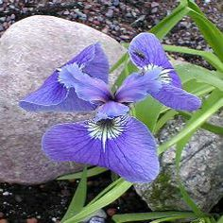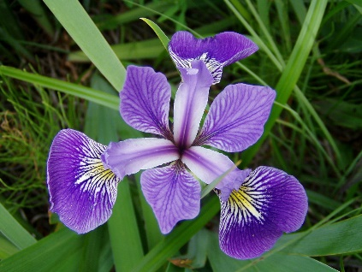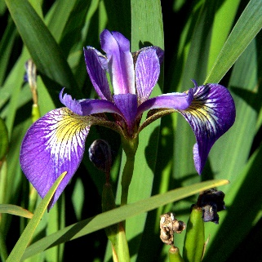

Some data that it is reasonable to analyze by hand:

Measured percentage fat in egg whites

Lab 1 |  | Lab 2 |  | Lab 3
0.24 |  | 0.18 |  | 0.27
0.34 |  | 0.29 |  | 0.37
0.55 |  | 0.3 |  | 0.37
0.62 |  | 0.33 |  | 0.38
0.65 |  | 0.39 |  | 0.42
0.68 |  | 0.4 |  | 0.45
0.76 |  | 0.4 |  | 0.46
0.8 |  | 0.43 |  | 0.54

Width of the aedeagus of the concinna flea beetle (in microns)

134
137
140
141
142
143
144
144
144
147
147
147
148
148
149
150
150
151
153
154
157

