Slicing 3D shapes name:
Use the Cross Section page at Shodor Interactivate: http://www.shodor.org/interactivate/activities/CrossSectionFlyer/
1. Choose a Prism with 4 lateral faces to get a cube
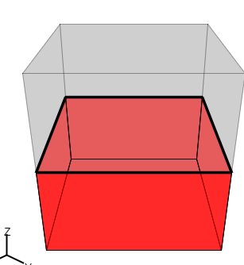
a. Move the rotate slice around Y slider to the middle to get a horizontal cross section/slice. What shape is it? (Note: the cross section is shown on the right)

b. What happens to the shape of the cross section when you move the slice up and down (perpendicular to the base—use the Move Slice slider)?

c. What other shapes can you get by rotating the slices? (Use the Rotate slice around Y and Rotate slice around Z sliders.) Find and draw 3 more shapes you can get as slices.

2. Make a pyramid with a square base by choosing pyramid and 4 lateral faces.
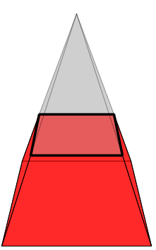

a. What is the shape of a slice parallel to the base?

b. What happens to the cross section (slice) when you move it up and down?

