Graphing and data practice problems:

On the next page you will find 7 data sets. Different kinds of graphs are appropriate for different kinds of data sets.
Line graph-- good for seeing trends over time
Scatter plot-- good for seeing relationships between paired data
Circle Graph--good for seeing parts of a whole
Bar graph-- Use with category data. Good for showing frequencies.
Histogram--good for displaying number data that is grouped into intervals.
Box plot--good for seeing central tendency (what is typical of data), and especially for comparing two data sets
Line (dot) plot—good for showing central tendency of a single data set.

Task 1: for each of the data sets, list the kinds of graphs that it would be reasonable to make from the data.

Task 2: I chose each of these data sets to be particularly good for one of the types of graph above, see if you can find the best way to match up types of graphs and data sets, and make a graph for each data set.

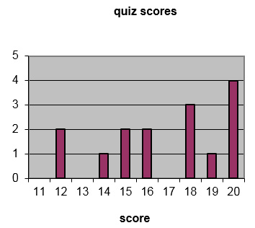
Task 3: Try to figure out the original data based on the quiz scores bar graph given below. Use what you know about the original data to find the
a. mean,
b. mean absolute deviation,
c. median,
d. mode,
e. upper and lower quartile for the data.
f. Make a stem and leaf plot for the data

Extra questions:
4. If I made a circle graph/pie chart with the data below, how many degrees should each pie wedge be?
Favorite pet frequency
Dog | 9
Cat | 4
Bird | 5
Rabbit | 2

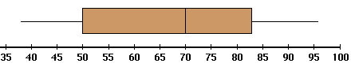
5. The data for this graph was collected from 80 people. What is the median?
What is the upper quartile?
About how many people scored above 70%?
How many scored above 83%?

6. Give two examples of category data, and two examples of numerical data you could collect with elementary aged children. List 3 kinds of graphs you can make for category and 3 kinds you can make for numerical data.

7. What is the difference between a bar graph and a histogram?

A. B. C. D.
avg spending on alcohol products  in a particular county | avg spending on tobacco products in a particular county |  | age | height |  | type of animal at shelter |  | name | birth month
 |  |  | 0 | 26” |  | cat |  | Jen | Feb
 |  |  | 1 | 31” |  | dog |  | Dave | Sept
 |  |  | 2 | 35” |  | dog |  | Sarah | Oct
 |  |  | 3 | 39” |  | cat |  | Paul | Feb
 |  |  | 4 | 41” |  | cat |  | Nick | Mar
6.47 | 4.03 |  | 5 | 43” |  | cat |  | Anna | July
6.13 | 3.76 |  | 6 | 46” |  | other |  | Alice | July
6.19 | 3.77 |  | 7 | 48” |  | cat |  | Fred | May
4.89 | 3.34 |  | 8 | 51” |  | cat |  | Mike | Aug
5.63 | 3.47 |  | 9 | 53” |  | dog |  | Joan | Jan
4.52 | 2.92 |  | 10 | 55” |  | dog |  | Lisa | July
5.89 | 3.20 |  | 11 | 58” |  | cat |  | Carl | May
4.79 | 2.71 |  | 12 | 61” |  | other |  | Ted | Aug
5.27 | 3.53 |  | 13 | 66” |  | cat |  | Arnold | June
6.08 | 4.51 |  | 14 | 68” |  | cat |  | Liz | Nov
4.02 | 4.56 |  | 15 | 71” |  | dog |  | Jack | June
E. F. G.
#candies in 1 oz bag brand A | #candies in 1 oz bag brand B |  | name | height in cm. |  | Number of buttons on our clothes
18 | 20 |  | Jen | 164 |  | 6
19 | 24 |  | Dave | 181.5 |  | 1
24 | 26 |  | Sarah | 169 |  | 1
20 | 21 |  | Paul | 178 |  | 3
17 | 20 |  | Nick | 179 |  | 5
21 | 16 |  | Anna | 165.5 |  | 3
20 | 18 |  | Alice | 160 |  | 5
19 | 16 |  | Fred | 183 |  | 1
22 | 22 |  | Mike | 187 |  | 0
20 | 23 |  | Joan | 158 |  | 0
22 | 22 |  | Lisa | 165 |  | 1
21 | 25 |  | Carl | 181 |  | 2
18 | 19 |  | Ted | 172 |  | 5
20 | 17 |  | Arnold | 180 |  | 3
22 | 20 |  | Liz | 166 |  | 6
21 | 25 |  | Jack | 176 |  | 0

