HW: Find the volume of each of these: name:

1.

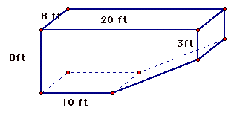

Area of base:

Height:

Volume:

2.

Area of base:

Height:

Volume:

3 .

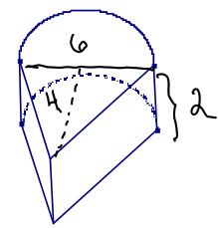

Area of base:

Height:

Volume:

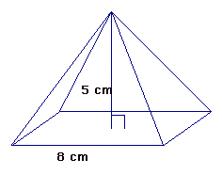4.

Area of base:

Height:

Volume:

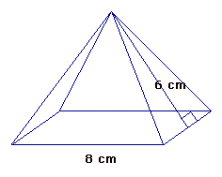5.

Area of base:

Height:

Volume