Surface area practice:

1.

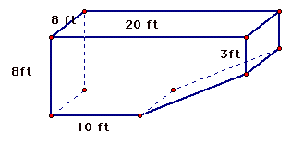

Area of base:

Other areas:

Total surface area:

2.

Area of base:

Other areas:

Total surface area:

3 .

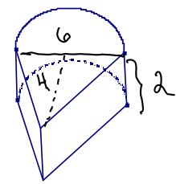

Area of base:

Other areas:

Total surface area:

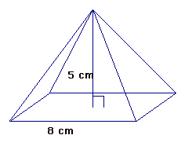4.

Area of base:

Other areas:

Total surface area:

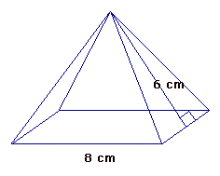5.

Area of base:

Other areas:

Total surface area: