Probability practice problems:

1. Make a table to answer: if I roll 2 regular 6-sided dice:

1. What is the probability that you roll a 6 on at least one die
2. What is the probability that the sum is at most 4?
3. What is the most likely sum, and what is it’s probability?

|  |  |  |  |  |  |  |
| --- | --- | --- | --- | --- | --- | --- |
|  | 1 | 2 | 3 | 4 | 5 | 6 |
| 1 | 1+1=2 | 1+2=3 | 1+3=4 | 1+4=5 | 1+5=6 | 1+6=7 |
| 2 | 2+1=3 | 2+2=4 | 2+3=5 | 2+4=6 | 2+5=7 | 2+6=8 |
| 3 | 3+1=4 | 3+2=5 | 3+3=6 | 3+4=7 | 3+5=8 | 3+6=9 |
| 4 | 4+1=5 | 4+2=6 | 4+3=7 | 4+4=8 | 4+5=9 | 4+6=10 |
| 5 | 5+1=6 | 5+2=7 | 5+3=8 | 5+4=9 | 5+5=10 | 5+6=11 |
| 6 | 6+1=7 | 6+2=8 | 6+3=9 | 6+4=10 | 6+5=11 | 6+6=12 |

a. 11/36

b. 6/36=1/6

c. 7, 6/36=1/6

2. Make an area (table) diagram, and use it to answer:

If you spin two spinners that have these faces, and add the numbers, what is the most likely sum, and what is the probability of that sum?



|  |  |  |  |
| --- | --- | --- | --- |
|  | 1 | 2 | 3 |
| 2 | 2+1=3 | 2+2=4 | 2+3=5 |
| 3 | 3+1=4 | 3+2=5 | 3+3=6 |

Most likely sum is 4, P(sum of 4)=1/12+4/12=5/12

3. Make a tree diagram, and use it to answer: If I have 6 red socks, and 2 blue socks, what is the probability that two chosen at random will match?

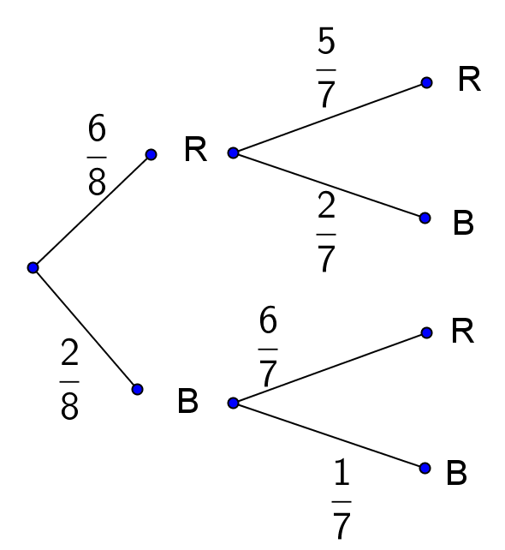

 (add top and bottom branches)

4. Use a complement to answer: If I spin both of these spinners, what is the probability that at least one of them will land on “A”?

Complement: neither lands on A

P(Complement) = 

P(at least one A)=

5. If I roll two 8-sided dice, the probability that I do not get 1 on either die is . What is the complement of not getting a 1 on either die?

The complement is: Getting a 1 on at least one die.

6. Use a complement to solve: If I roll three 8-sided dice, what is the probability that there is at least one match (I roll the same number twice)?

a. The complement is.... no matches

b. The probability of the complement is.... 

c. The probability of getting at least one match is... 