Identifying Prisms and Pyramids:

1. Give a definition of a prism. Make sure that an anti-prism does not satisfy your definition.

2. Here are some pictures of 3-D objects.

* For each shape, tell whether it is a prism, a pyramid or neither
* If it is a prism or a pyramid, shade in a face that would be the base of the prism or pyramid.

d

 

c

b

a





f

e



h

g



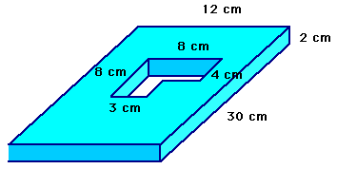

j

i

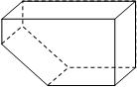

n

m

l

k