Parallelograms, triangles and trapezoids name:

1. **Draw** a rectangle with equal area to this parallelogram.

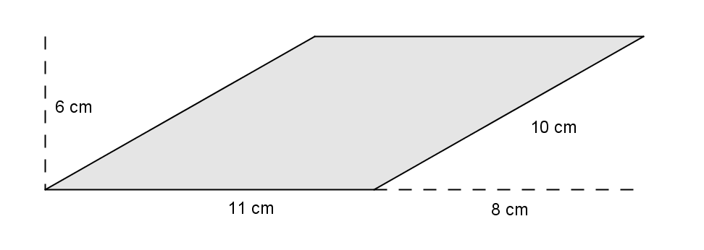

**Explain** how we know the areas are the same.

2. Draw a rectangle with equal area to this parallelogram, where one of its sides is the same as the 5 cm side on this parallelogram:

5 cm

2 cm

3. For each of these triangles, draw in a segment that shows the height of the triangle, given that the bold side is the base.

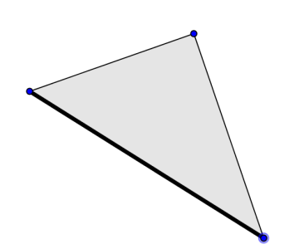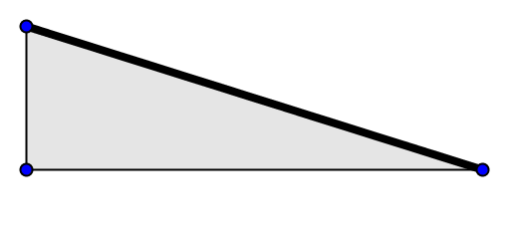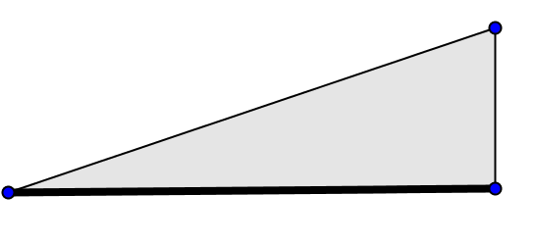

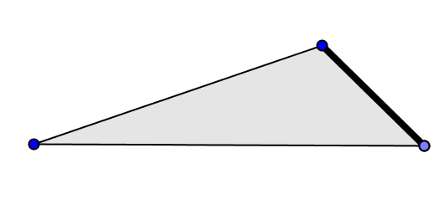

4. For each of these triangles, draw another congruent triangle (same shape and size) next to it, so that the two triangles together make a parallelogram. Put the triangles together in such a way that the bold edge of the triangle is one of the edges of the parallelogram (on the outside of the parallelogram) so it can be the base.

 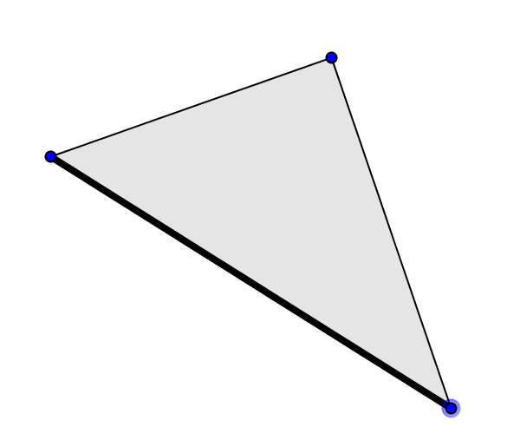

 

**Write:** How do we get the area of a triangle formula from these pictures?

5. Trapezoids. Draw or trace and cut out a trapezoid or two like the one below.

a. Figure out how to cut the trapezoid into two shapes you already know (triangles or parallelograms) that have measurements that you can figure out from **b, B,** and **h.**

b. Cut out two identical trapezoids. Figure out how to put them together to make a shape you already know (triangle or parallelogram). On a separate sheet of paper, show what you did with the trapezoid(s).

