Geoboard and grid areas and perimeters name:

1. What are the two most common errors people make when finding lengths on a geoboard or grid?

2. What common mistakes might you see when children are finding the perimeter of a compound shape like this (there is another mistake besides those in #1)



3. Find the area and perimeter of this triangle. What makes finding the area tricky? What makes finding the perimeter tricky?



4. Find the area and perimeter of this shape. Explain your reasoning:



5. Use the grid to help you estimate the area and perimeter of the bear in the units shown by the grid.

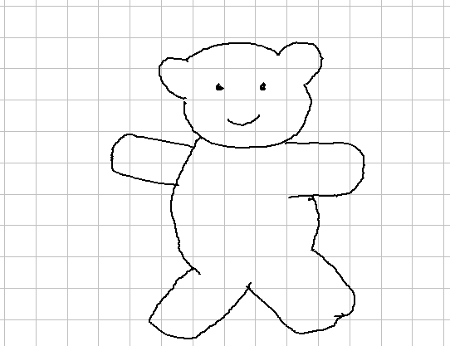

6. Make 3 rectangles with the same perimeter and different areas:

7. Make 3 rectangles with the same area and different perimeters.