More decimal and percent practice:

1. Represent .32 on a number line.

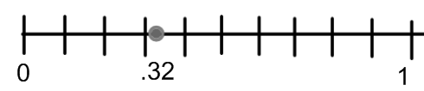

2. Fill in the blanks with decimal place value words:

When you are adding 2.89 + 4.25, and you combine .09 and .05, you write 4 in the _**hundredths**__ place, and you trade ten ____**hundredths**_____ for one ____**tenth**_______

3. Show how to multiply 1.7 × 2.4 on this grid, labelling the place-value partial products. Combine the partial products to find the total product

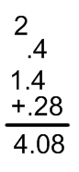 

.4

2



.28

1.4

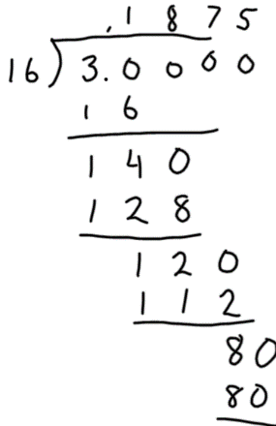4. Show how to multiply 3.6 × 2.37 using fractions. Convert back to decimals at the end.

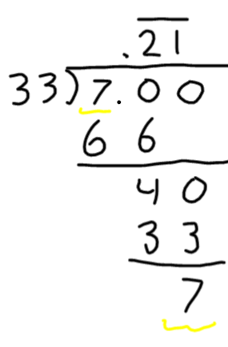



5. Convert each fraction to a decimal using long division:

a. 3/16 b. 7/33

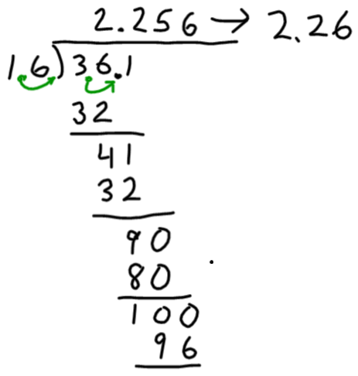6. Show that 4.9 ÷ .27 = 490 ÷ 27 by using fractions and the fraction division algorithm.



7. Show how to compute by long division:

3.61 ÷ 1.6 (round to the nearest hundredth)

8. If you multiply with units: 3.6 m. × 2.37 m. what are the units of your answer at the end? m2

9. If you divide with units 3.61 m. ÷ 1.6 m. what are the units of your answer at the end? There are no units (the answer is a number of groups)

10. What is the simplified fraction form of 4.8% (numerator and denominator must both be whole numbers)?



12. Solve by algebra:

a. What percent of 85 is 30? (round to nearest percent)

85 is x % of 30



b. 40 is 70% of what? (round to nearest whole number)

40 is 70% of x



c. 65% of 90 is what? (round to the nearest whole number)

x is 65% of 90



13. Solve using a grid:

a. b.

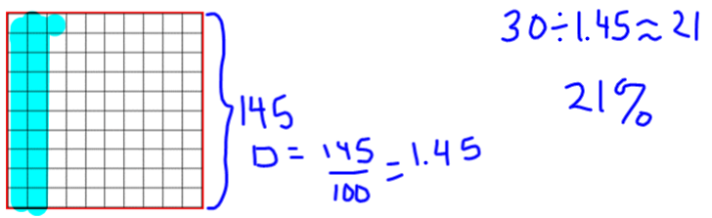 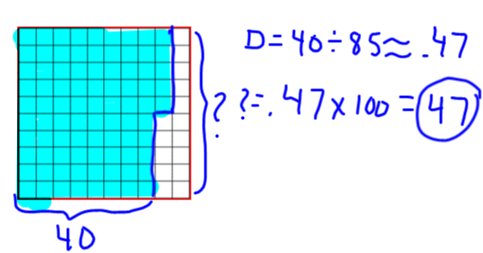

c. 135% of 42 is what?

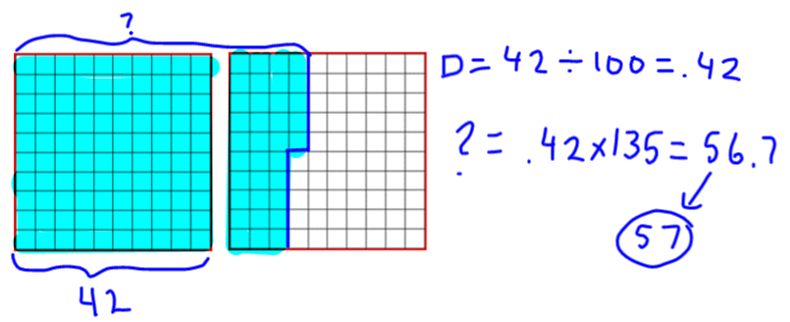

|  |  |
| --- | --- |
| 14. a. An item that was $82 is on sale for $59. What percent discount is that?  59 is x% less than 82.  59 is y% of 82, and x% = 100% - y% |  |

|  |  |
| --- | --- |
| b. The selling price of a house rises from $120,000 to $265,000 over a period of 15 years. What percent increase is that?  265,000 is x % more than 120,000  265,000 is y% of 120,000 and x% = y% - 100% | c. The price of gas went down by 23% from $4.12/gallon. What is the new price?  x is 23% less than $4.12  100%-23%=77%  x is 77% of $4.12  . The new price is $3.17 |

d. The price of gas went up by 12% to $3.60/gallon. What was the old price?

$3.60 is 12% more than x

$3.60 is 112% of x

 The price was $3.21

15. Solve using grids:

a. The price of oil went up from $70/barrel by 20% and then it went down from the new price by 20%. What is the price of oil now?

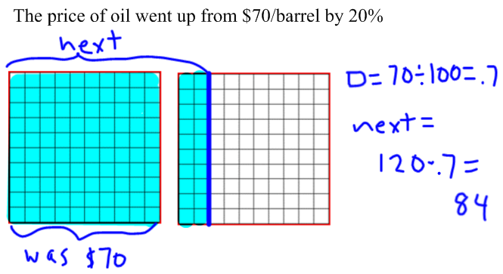 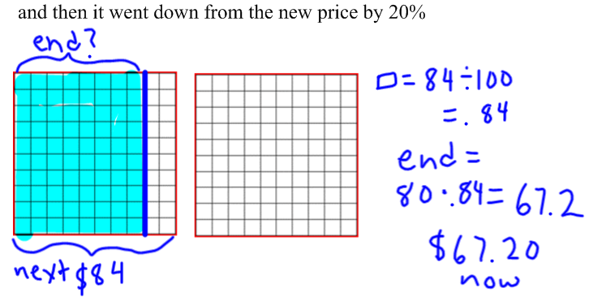

|  |  |
| --- | --- |
| b. The market value of a car decreased from $24,000 to $1750. What percent decrease is that? | c. The sale price of a chair that is $40% off is $27. What was the original price? |