name:

1. Kind of data _________________

|  |  |
| --- | --- |
| pepperoni  cheese  pepperoni  mushroom  cheese  cheese  mushroom  olive  cheese  cheese  pepperoni  cheese  pepperoni  cheese  pepperoni  cheese  mushroom |  |



2. Kind of data _________________ and _____________________

|  |  |  |  |  |  |  |  |  |
| --- | --- | --- | --- | --- | --- | --- | --- | --- |
| 8 3/4 | 9 | 9 | 9 | 9 | 9 1/4 | 9 1/4 | 9 1/2 | 9 1/2 |
| 9 1/2 | 9 3/4 | 9 3/4 | 10 | 10 | 10 1/4 | 10 1/4 | 11 | 11 |

3. Explain two differences between a bar graph and a histogram.

4. What should this graph have that’s missing? 5. What’s wrong with this graph?

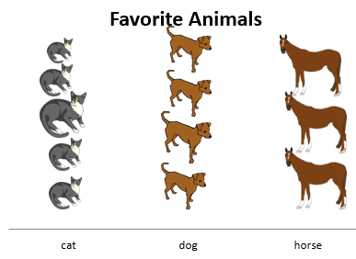

6. What should this graph have that’s missing?

|  |  |  |  |  |  |  |  |
| --- | --- | --- | --- | --- | --- | --- | --- |
| X |  | X  X  X | X  X  X  X | X  X  X  X  X  X | X  X | X | X  X |
| 5 | 6 | 7 | 8 | 9 | 10 | 11 | 12 |

7. What’s wrong/what’s missing in this graph?

**Handspan lengths**

|  |  |  |  |  |  |  |  |  |  |  |  |
| --- | --- | --- | --- | --- | --- | --- | --- | --- | --- | --- | --- |
| X | X  X | X  X | X  X  X  X | X | X  X  X | X  X | X  X  X | X | X  X  X  X | X  X  X | X |
| 17.5 | 19 | 19.5 | 20 | 20.5 | 21 | 21.5 | 22 | 22.5 | 23 | 23.5 | 24 |

**Span in cm**