Scaling picture problems:

Fill in the missing scale factor, lengths and areas for these pairs of similar shapes:

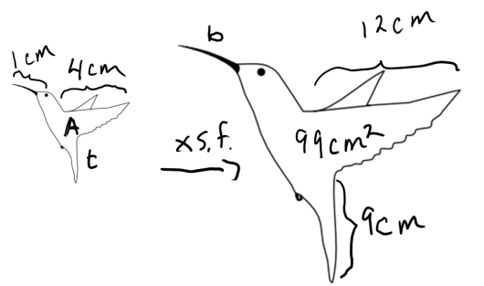

|  |  |  |  |
| --- | --- | --- | --- |
| 1. | original | scale factor | new |
| beak | 1 cm |  |  |
| wing | 4 cm |  | 12 cm |
| tail |  |  | 9 cm |
| Area |  |  | 99 cm2 |



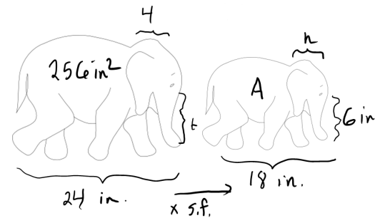

|  |  |  |  |
| --- | --- | --- | --- |
| 2. | original | scale factor | new |
| trunk |  |  | 6 in |
| length | 24 in |  | 18 in |
| head | 4 in |  |  |
| area | 256 in2 |  |  |

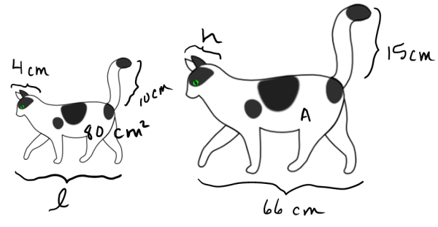

|  |  |  |  |
| --- | --- | --- | --- |
| 3. | original | scale factor | new |
| length |  |  | 66 cm |
| tail | 10 cm |  | 15 cm |
| head | 4 cm |  |  |
| area | 80 cm2 |  |  |



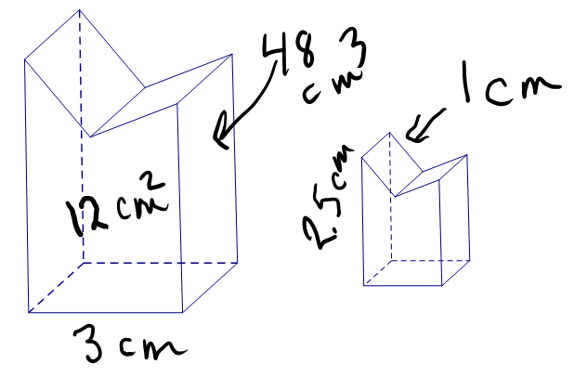

|  |  |  |  |
| --- | --- | --- | --- |
| 4. | original | scale factor | new |
| width | 3cm | x 1/2 = |  |
| height |  |  | 2.5 cm |
| diagonal |  |  | 1 cm |
| front area | 12 cm2 |  |  |
| volume | 48 cm3 |  |  |

|  |  |  |  |
| --- | --- | --- | --- |
| 5. | original | scale factor | new |
| length | 16 cm |  | https://encrypted-tbn0.gstatic.com/images?q=tbn:ANd9GcTnfmZ1K4XyQs0-_eNcGxmBqv_cgah45lYiUHDHxPlA8dKtE88o |
| height | 2.6 cm |  |  |
| triangle area | 3.8 cm2 |  |  |
| volume | 3 cm3 |  |  |
| weight | 50 g |  | 400 g |

Answers



|  |  |  |  |
| --- | --- | --- | --- |
| 1. | original | scale factor | new |
| beak | 1 cm | x3= | 3 cm |
| wing | 4 cm | x3= | 12 cm |
| tail | 3 cm | x3= | 9 cm |
| Area | 11 cm2 | x3x3= | 99 cm2 |





|  |  |  |  |
| --- | --- | --- | --- |
| 2. | original | scale factor | new |
| trunk | 8 in | x3/4= | 6 in |
| length | 24 in | x3/4= | 18 in |
| head | 4 in | x3/4= | 3 in |
| area | 256 in2 | x(3/4)2= | 144 in2 |



|  |  |  |  |
| --- | --- | --- | --- |
| 3. | original | scale factor | new |
| length | 44 cm | x3/2= | 66 cm |
| tail | 10 cm | x3/2= | 15 cm |
| head | 4 cm | x3/2 | 6 cm |
| area | 80 cm2 | x(3/2)2= | 180 cm2 |





|  |  |  |  |
| --- | --- | --- | --- |
| 4. | original | scale factor | new |
| width | 3cm | 1/2 | 1.5 cm |
| height | 5 cm | x1/2= | 2.5 cm |
| diagonal | 2 cm | x1/2= | 1 cm |
| front area | 12 cm2 | x1/4= | =3cm2 |
| volume | 48 cm3 | x1/8= | =6 cm3 |

|  |  |  |  |
| --- | --- | --- | --- |
| 5. | original | scale factor | new |
| length | 16 cm | x2= | https://encrypted-tbn0.gstatic.com/images?q=tbn:ANd9GcTnfmZ1K4XyQs0-_eNcGxmBqv_cgah45lYiUHDHxPlA8dKtE88o32 cm |
| height | 2.6 cm | x2= | 5.2 cm |
| triangle area | 3.8 cm2 | x4= | 15.2 cm2 |
| volume | 3 cm3 | x8= | 24 cm3 |
| weight | 50 g | x8= | 400 g |