Scale factor and area problems name:
Note: Your default assumption should be that shapes are proportional unless there is information to tell you that they are not proportional.
1. I drew two pictures of a school. If the larger picture is twice as wide and 3 times as high as the smaller picture, by what factor has the area increased?  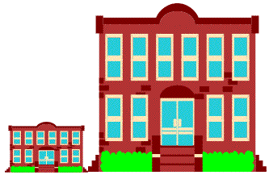 | Is it proportional?  What is the area scale factor?
2. I have two pictures of a star. The smaller star has an area of 5 cm2. If the larger star is 3 times as wide and 4 times as high as the smaller star, what is its area? | Is it proportional?  What is the area?
3. I have two pictures of a tree. the smaller picture was made from the larger picture by compressing by a scale factor of 1/2 vertically, and 1/2 horizontally. If the smaller picture has an area of 6 cm², what is the area of the larger tree? | Is it proportional?  What is the area?
4. I have two similar (proportional) pictures of a moon and star. The larger picture was enlarged by 200% on a standard copy machine from the smaller one:  a. If the area of the smaller star is 5 cm², what is the area of the larger star?  b. If the area of the larger moon is 48 cm², what is the area of the smaller moon? | a.  b.
5. I have a small picture of the famous painting the Mona Lisa. My picture is 1/5 as wide as the original painting. If my picture is 24 in², what is the area of the original painting? | Is it proportional?  What is the area?

