Ways of writing ratios name:
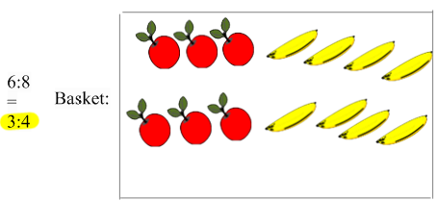
1. The ratio of apples to bananas in the basket is 3:4

a. The ratio of bananas to apples is___________

b. _______ of the pieces of fruit are apples

c. _______ of the pieces of fruit are bananas

d. There are ________ as many apples as bananas

e. There are _______ times as many bananas as apples

f. _______% of the fruit is apples

g. _____% of the fruit is bananas

2. 3/4 of the fish in my aquarium are goldfish, the rest are blue guppies.
Add fish to these aquariums so that
*the two aquariums have different numbers of fish in them and
*both of the aquariums fit the above description of my aquarium

Fill in the blanks so that each statement says the same thing as my original statement:

a. ______ of the fish in my aquarium are not goldfish

b. The ratio of goldfish to guppies is _____________

c. The ratio of guppies to goldfish is _____________

d. There are ______ (times) as many gold fish as guppies

e. There are _______(times) as many guppies as goldfish.

f. _______% of the fish in my aquarium are goldfish

g. _______% of the fish in my aquarium are guppies
3. The ratio of boys to girls in Mrs Triangle's class is 2:3

a. The ratio of girls to boys is_____________

b. There are _______ (times) as many boys as girls.

c. There are _______ (times) as many girls as boys.

d. _______ of the children are boys.

e. _______ of the children are girls.

f. ________% of the children are boys

g. ________% of the children are girls.

4. There are 2/3 as many horses as cows in the field

There are (times) as many cows as horses

a. of the animals in the field are horses

b. of the animals in the fields are cows.

c. The ratio of cows to horses is: _

d. The ratio of horses to cows is: _

e. % of the animals in the field are cows

f. % of the animals in the field are horses

