Ratio problems and examples from Eureka Math at commoncore.org (Grade 6)

Exploratory Challenge
A t-shirt manufacturing company surveyed teen-aged girls on their favorite t-shirt color to guide the company’s decisions about how many of each color t-shirt they should design and manufacture. The results of the survey are shown here.
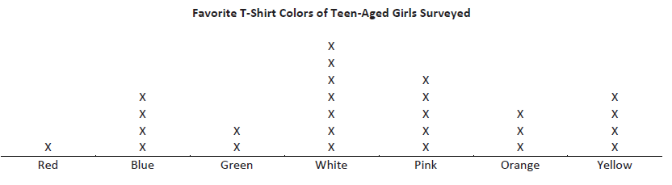
Exercises for Exploratory Challenge
1.Describe a ratio relationship, in the context of this survey, for which the ratio is 3: 5.

2.For each ratio relationship given, fill in the ratio it is describing.
Description of the Ratio Relationship  (Underline or highlight the words or phrases that indicate the description is a ratio.) | Ratio
For every 7 white t-shirts they manufacture, they should manufacture 4 yellow t-shirts. The ratio of number of white t-shirts to number of yellow t-shirts should be…
For every 4 yellow t-shirts they manufacture, they should manufacture 7 white t-shirts. The ratio of number of yellow t-shirts to number of white t-shirts should be…
The ratio of number of girls who liked a white t-shirt best to number of girls who liked a colored t-shirt best was…
For each red t-shirt they manufacture, they should manufacture 4 blue t-shirts. The ratio of number of red t-shirts to number of blue t-shirts should be…
They should purchase 4 bolts of yellow fabric for every 3 bolts of orange fabric. The ratio of number of bolts of yellow fabric to number of bolts of orange fabric should be…
The ratio of number of girls who chose blue or green as their favorite to the number of girls who chose pink or red as their favorite was …
Three out of every 26 t-shirts they manufacture should be orange. The ratio of number of orange t-shirts to total number of t-shirts should be…

Exercise 2
Shanni and Mel are using ribbon to decorate a project in their art class. The ratio of the length of Shanni’s ribbon to the length of Mel’s ribbon is 7: 3.
Draw a tape diagram to represent this ratio:

Exercise 3
Mason and Laney ran laps to train for the long-distance running team. The ratio of the number of laps Mason ran to the number of laps Laney ran was 2 to 3.
a. If Mason ran 4 miles, how far did Laney run? Draw a tape diagram to demonstrate how you found the answer.

b. If Laney ran 930 meters, how far did Mason run? Draw a tape diagram to determine how you found theanswer.

c. What ratios can we say are equivalent to 2:3?

Exercise 4
Josie took a long multiple-choice, end-of-year vocabulary test. The ratio of the number of problems Josie got incorrect to the number of problems she got correct is 2:9.
a.If Josie missed 8 questions, how many did she get right? Draw a tape diagram to demonstrate how you foundthe answer.

Exercises
1.The ratio of the number of people who own a smartphone to the number of people who own a flip phone is 4:3. If 500 more people own a smartphone than a flip phone, how many people own each type of phone?

2.Sammy and David were selling water bottles to raise money for new football uniforms. Sammy sold 5 water bottles for every 3 water bottles David sold. Together they sold 160 water bottles. How many did each boy sell?

Draw a tape/bar diagram and show how to use it to solve each of these problems:
3. Ms. Johnson and Ms. Siple were folding report cards to send home to parents. The ratio of the number of repor tcards Ms. Johnson folded to the number of report cards Ms. Siple folded is 2:3. At the end of the day, Ms. Johnson and Ms. Siple folded a total of 300 report cards. How many did each person fold?

4.At a country concert, the ratio of the number of boys to the number of girls is 2:7. If there are 250 more girls than boys, how many boys are at the concert?

5. Last summer, at Camp Okey-Fun-Okey, the ratio of the number of boy campers to the number of girl campers was8:7. If there were a total of 195 campers, how many boy campers were there? How many girl campers?

6. The Speedy Fast Ski Resort has started to keep track of the number of skiers and snowboarders who bought season passes. The ratio of the number of skiers who bought season passes to the number of snowboarders who bought season passes is 1:2. If 1250 more snowboarders bought season passes than skiers, how many snowboarders and how many skiers bought season passes?

