Data practice questions:
1. What are some good kinds of graphs for category data? bar graphs, picture graphs
2. What are some good kinds of graphs for numerical/measurement data? line plots, histograms, boxplots
3. Draw a line plot for this data (pencil lengths in inches):
4, 4, 4, 4, 4 1/2, 5, 5, 5, 5, 5 1/2, 5 1/2, 5 1/2, 6, 6, 6, 7, 7, 7

X  X  X  X | X | X  X  X  X | X  X  X | X  X  X |  | X  X  X
4 | 4 1/2 | 5 | 5 1/2 | 6 | 6 1/2 | 7

4. Draw a scaled picture graph to show this data (where the scale is not a unit scale).
Favorite fruit:
Banana: 5
Grapes: 8
Apple: 3
Orange: 4
Our Favorite Fruit
 | Banana | Grapes | Apple | Orange

Scale: one picture of fruit = 2 people

5. Find the minimum, lower quartile, median, upper quartile and maximum for each of these data sets, and make box plots on a common number line to compare the data:
#candies in 1 oz bag brand A | #candies in 1 oz bag brand B
18 | 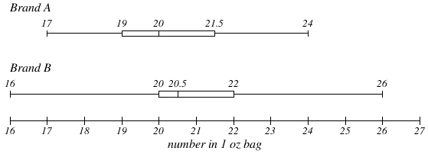  20
19 | 24
24 | 26
20 | 21
17 | 20
21 | 16
20 | 18
19 | 16
22 | 22
20 | 23
22 | 22
21 | 25
18 | 19
20 | 17
22 | 20
21 | 25

6. Make a histogram with interval size 5 showing the data:
height in cm.
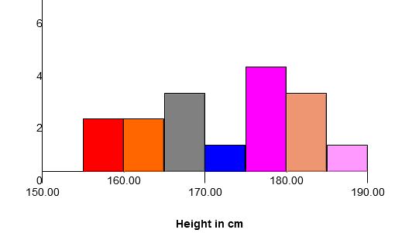
164
181.5
169
178
179
165.5
160
183
187
158
165
181
172
180
166
176

7. Find the mean and mean absolute deviation for the data in problem 6.
Mean = 172.8. MAD = 7.9

8. Which measure of variation is recommended for comparing two data sets that are symmetrically distributed? Mean Average Deviation

9, Which measure of variation is recommended for comparing two data sets that are asymmetrically distributed? Interquartile Range

10. The data for this graph was collected from 80 people. What is the median?
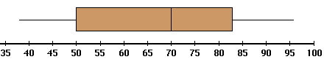
What is the upper quartile?
About how many people scored above 70%?
How many scored above 83%?

The median is 70, the upper quartile is about 83. About 40 people (half of 80) scored above the median which is 70.
About 20 people (a quarter of 80) scored above the upper quartile which is 83.

11. This is a pair of boxplots of the labor force participation rate of women in 19 U.S. cities in the years 1968 and 1972. Compare the amount and deviation of labor force participation between the two years.
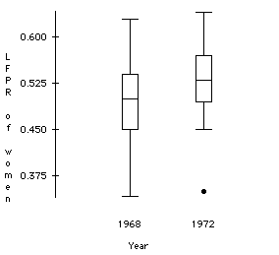
More women participated in the workforce in 1972 (the median was higher than in 1968, and the lower quartile in 1972 is about what the median was in 1968).
There was more variation in workforce participation in 1968 than in 1972 (the interquartile range was larger in 1968).

