|  |  |
| --- | --- |
| 1. a. On this grid make a rectangle with dimensions | b. On this grid make a rectangle with dimensions |

c. Show and explain why the areas are equal by dissecting and reassembling.

2. A B C

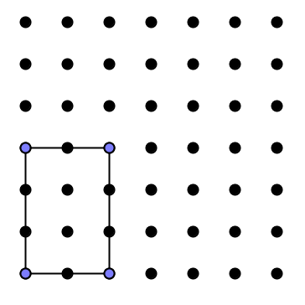 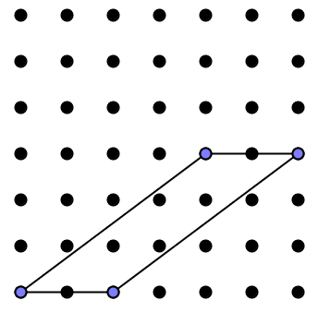 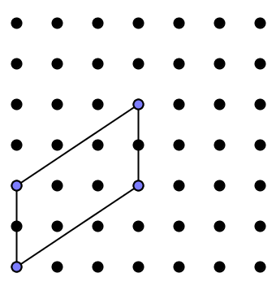

a. Show and explain why A and B have the same area

b. Show and explain why A and C have the same area



d. Find another shape with the same area and draw it on this grid. Explain how you know it has the same area

   

   

   

   

   