Two more Venn diagram practice problems:

1. I have 12 things in my pencil box.

6 of the things are pens

9 of the things are not blue

4 of the things are neither blue nor are pens

How many blue pens are in my pencil box?

2. I have 143 books in my office

80 of them are textbooks

72 of them are not hard cover books

48 of the hard cover books are not textbooks

How many books in my office are not textbooks and do not have a hard cover?

One more working backwards practice problem

3. Jane’s pattern block trees look like this:

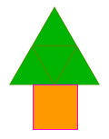 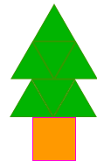 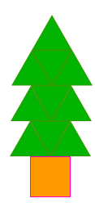

1 year old 2 year old 3 year old

(4 green 1 orange 7 green 1 orange 10 green 1 orange)

a. Show how to find the number of pattern blocks in a 8 year old tree.

b. Show how to figure out what the biggest tree you could build with 45 blocks would be.

c. Show how to figure out what the biggest tree you could build with 151 blocks would be

d. Explain how to figure out what the biggest tree you could build with N blocks would be

Solutions:

1. 1 blue pen



2. 16 are neither



3. a. 3x8 for the 3 triangles across + 2 for the top and bottom: 26 pattern blocks

b. 2 blocks on top and bottom, so 43 blocks to use for the middle.

divide 43 by 3 blocks per row is 14 with a remainder of 1. Round down, because we have don’t have enough for another row, so it would be a 14 year old tree.

c. 151 – 2 = 149

149/3 = 49 R 2

49 year old tree.

d. Many correct answers:

|  |  |  |
| --- | --- | --- |
| subtract 2 (for 2 on top and bottom)  divide by 3 (because 3 blocks per row)  round down/throw away remainder. | (N-2)/3 and round down | Divide N by 3. If the remainder is 2 then the quotient is the answer, if the remainder is 1 or 0, subtract 1 from the quotient because there aren’t enough blocks for the top and bottom. |

Explain how to figure out what the biggest tree you could build with N blocks would be