Overview
Background children have from prior instruction:

In second grade children learned that multiplication can be computed by repeated addition and that division corresponds to grouping into equal groups (both measurement (groups of __) and partitive (__ equal groups)). Children did mostly multiplying and dividing by 2 and 3, and did it mostly by direct modeling.

Children are pretty good at adding on 1 digit numbers so they should be able to do multiplication as repeated addition using numbers, and they should need less time direct modeling with discrete counters. Maybe Cuisenaire rods would be helpful for multiplication.
Goals for instruction (content in the unit that children should learn)

Multiplication is shown as repeated addition and as arrays. Division is shown with arrays too.
Commutative law: pg. 70 # 4 and pg 72 # 10 are showing the distributive law.
Fact families with multiplication and division: pg 72-3 #10-12 are fact family problems.
Multiplication rules for 0 and 1.
Children compare products and quotients (pg 74)
Children guess and check to find the right operation for 3 numbers (p. 74)
Drawing bar diagrams for word problems to decide whether to multiply or divide. (sec. 2)
Multiplication by tens, hundreds and thousands (multiplying by numbers that end in 0’s) (sec 3)
Put together multiplication problems to multiply 1 digit numbers by multidigit numbers. (sec 3)
g. Division with remainders with single digit divisors (by direct modeling and numerically) (sec 4: 2 digit divided by 1 digit)
Division by single digit numbers 3 and 4 digit divided by 1 digit (sec. 5)
Organization by section:

Sec 1: Multiplication by direct modeling and repeated addition.
Multiplication shown as arrays
Commutative law of multiplication
Multiplication rules for 0 and 1
Division by direct modeling and repeated
Write fact families from arrays.
Determine the correct operation given numbers
Compare using <,>,= results of adding, subtracting, multiplying and dividing.
Sec 2: bar diagrams for multiplication and division (pgs 77-79)
Sec 3: Multiply 1 digit numbers by hundreds, tens and thousands. (with manipulatives and the standard algorithm)
Multiply 2 digit numbers by 1 digit numbers
Multiply 3 and 4 digit numbers by 1 digit numbers
Sec. 4: Solve division problems with remainders dividing 2 digit numbers by 1 digit numbers. (with manipulatives and standard algorithm)
Numerical and word problems
Sec. 5: Solve division problems with remainders, dividing 3 digit numbers by 1 digit numbers.
(with manipulatives and standard algorithm)
Numerical and word problems

Lesson number/date and section number/name:  Lesson 1, first part of section 1 Looking Back | Materials:  SMART Notebook (or overhead projector slides) with problems and copies of the book pages.  Per pair of children:  --100 cubes or tiles  --Cuisenaire rods (6 of #1-4 and 4 of # 5-10)  Per child:  --1 piece of blank unlined paper  --Textbook  --Workbook  --Pencil
Big idea: review multiplication (multiplication as repeated addition, and bar and rectangle representations for multiplication)
Source(s):
pgs 68-73
Learning goals:
Represent multiplication with
--direct modeling
--repeated addition in a table
--Cuisenaire rods in a line and in a rectangle

3.OA.1.Interpret products of whole numbers, e.g., interpret 5 × 7 as the total number of objects in 5 groups of 7 objects each. For example, describe a context in which a total number of objects can be expressed as 5 × 7.
Description (detailed):
Children will push pairs of desks together to work with a partner, and collect the materials.
Directions:
- “Fold the blank paper into fourths and then to unfold it” (model doing this)
- “You see how there are 4 parts of this paper. In a minute I’m going to read you a problem, and you’re going to show in the top left part of the paper how you solved it. Hold up your paper and point to where you’re going to put your answer”
- “I want to see how you found the answer, and not just the number, so write or draw something that shows how you found the answer. You can use the cubes to find the solution or you can do something else, but please draw or write what you did.”
Display and read problem 1:
“There are 6 boxes of pencils. Each box has 4 pencils. How many pencils are there?”
Walk around and see what strategies children are using to solve the problem. Identify some students that are solving the problem by direct modeling, some that are using repeated addition, and look to see how many children are writing 4x6.

Invite children to share their work and solution. Have children fill in the remaining 3 parts of the the paper with an efficient (quick to draw) direct modeling picture, 4+4+4+4+4+4 and 4x6.

Have children get out the Cuisenaire rods. Review the numbers and colors by asking the children to show you the rods for #2, 4, 3, 6, 5 and 10.

Ask children: “With your partner, decide how to show the answers to this problem with Cuisenaire rods”. Choose someone to tell how they did that (6 purple rods). Have children make a long line of the purple rods. Explain that this is like adding 4+4+4+4+4+4+4—you are showing six 4’s end to end. Show how to draw that next to 4+4+4+4+4+4 (drawing it smaller to that it fits, and labeling each bar with the number 4). Tell children that we’re going to call this kind of picture a bar diagram.

Tell the children to put the bars side by side to make a short fat rectangle. This should be small enough to trace next to or over 4x6 on the page. Tell the children that you’re going to call this picture a rectangle diagram. Have children label the sides of the rectangle with 4 and 6.

Have children turn over their paper. Show a diagram of the paper, and where they should be writing the problem, drawing a picture, writing an addition sentence and bar diagram, and writing a multiplication sentence and rectangle diagram.

Reveal and read the next problem.
“Each piece of candy costs 3¢. How much do 5 pieces of candy cost?”
Walk around as children solve and represent the problem.

Invite 3 children to show their representations on the SMART Board. Ask children: “what is your favorite way to solve the problem?” Tell children that sometimes one representation is better, and sometimes another one is better.

Show problem #1 from the textbook: “A dog has 4 legs. How many legs do 7 dogs have?”
Discuss the patterns in the table. Make sure the following ideas are included: skip counting, repeated addition and multiplication.

Show the problem: “I made 6 apple pies last week. Each apple pie had 3 apples in it. How many apples did I use in all?” with a blank table. Fill in the labels and top row of the table. Have children copy and complete the table. Invite children to:
- Tell how many apples were used in all and how they found the answer
- Show the skip count pattern
- Finish the statement that describes the multiplication pattern.

Walk around and observe while children do Unit 3 Exercise 1 in their workbooks.

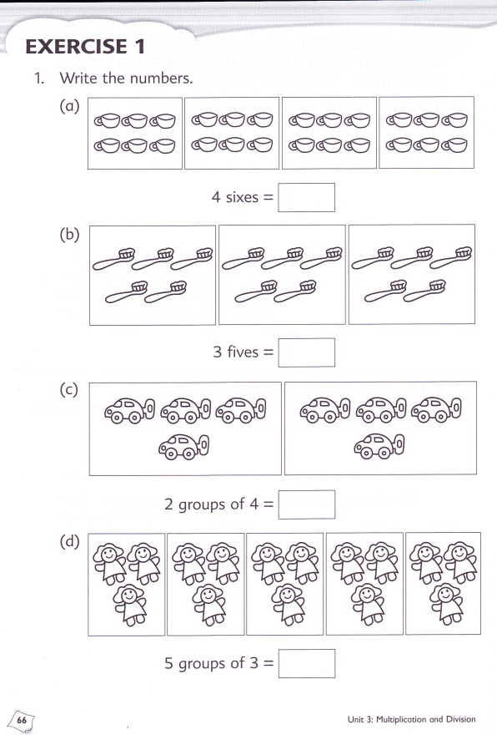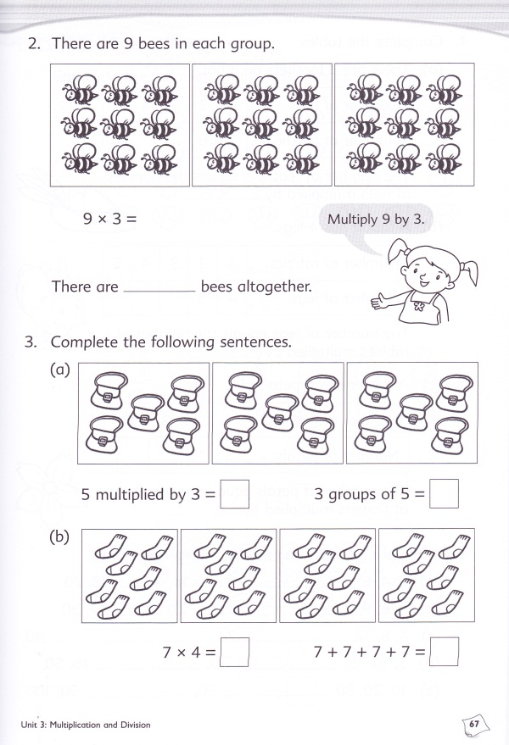

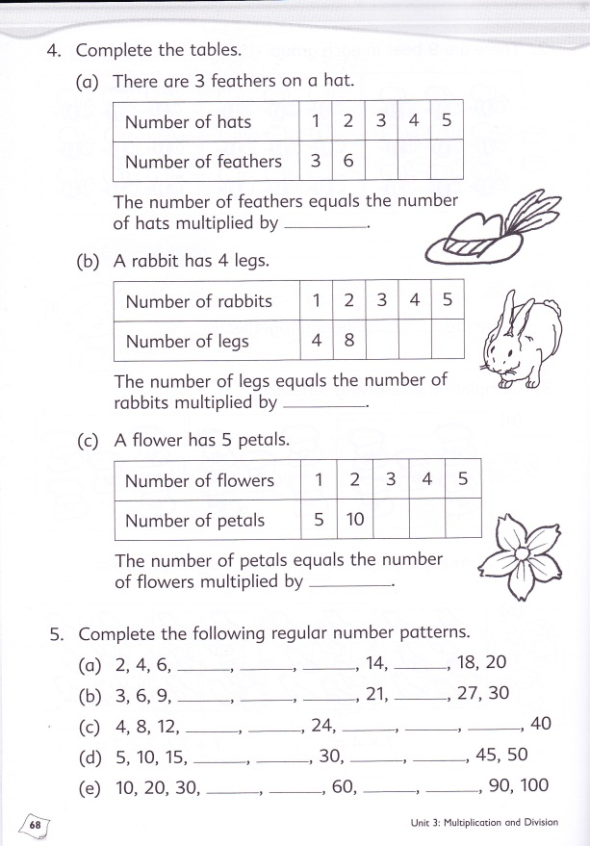

Lesson number/date and section number/name:  Lesson 2: second part of section 1 Looking Back | Materials:  SMART Notebook (or overhead projector slides) with problems and copies of the book pages.  Per pair of children:  --Cuisenaire rods (6 of #1-4 and 4 of # 5-10)  --cm grid paper (2 sheets per pair with extra available)  --Shuffled sets of 10 cards (A-10 single suit)  --A pair of dice  --Scratch paper  --bags of colored chips (20 per bag)  Each child:  --Pencil  --Scissors  --Workbook
Big Idea:
Commutative law
Source(s):

Learning goals: (include relevant standards from CCSS)
Commutative law of multiplication
Practice multiplication by choosing an easier repeated addition problem.
3.OA.5. Apply properties of operations as strategies to multiply and divide.² Examples: If 6 × 4 = 24 is known, then 4 × 6 = 24 is also known. (Commutative property of multiplication.) 3 × 5 × 2 can be found by 3 × 5 = 15, then 15 × 2 = 30, or by 5 × 2 = 10, then 3 × 10 = 30. (Associative property of multiplication.) Knowing that 8 × 5 = 40 and 8 × 2 = 16, one can find 8 × 7 as 8 × (5 + 2) = (8 × 5) + (8 × 2) = 40 + 16 = 56. (Distributive property.)
Description (detailed):
Demonstrate how to make arrays on the grid paper using Cuisenaire rods and a pair of numbers:
- Today you’re going to be making some rectangle diagrams on this grid paper, and cutting them out. With a partner, you’re going to get 8 cards. You and your partner are going to pick 2 cards. I turned over the cards 3 and 9. I’m going to make 3x9 by taking 3 of the 9 rods, and put them side by side to make a rectangle. Cuisenaire rods fit just perfectly on cm grid paper, so a 9 rod covers 9 squares. I’m going to trace my rectangle, and label it and cut it out. I’m going to trace lightly around each of my Cuisenaire rods so you can imagine how they look on the grid:
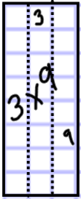
- My partner is going to make 9x3 by using 9 of the 3 rods. But I have a problem—I don’t have enough 3 rods. Does anyone have an idea about what I can do if I don’t have enough rods? [wait for suggestions] One thing I can do is I can trace the same 3 rods over and over until I have 9 traced onto the grid paper. When I’m done, I’m going to label it and cut it out, so then me and my partner will have two rectangles cut out and labeled.
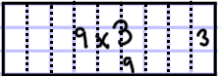
- You have 8 cards, so if you have use 2 cards each time, how many times can you do this? [4]. You and your partner will make 2 rectangles each time. How many cut out rectangles will you and your partner have together at the end? [8].
- How are you going to share the work between you and your partner? (Ask for suggestions such as: each pick 1 card and each make 1 rectangle, or, take turns picking cards.)
- OK, you’ll have 10 minutes to make rectangles, and then I’m going to ask you if you noticed any patterns in the rectangles you and your partner made.
- Everyone should have a pencil and scissors out on their desk. Please push your desk together with your partner. I want the partner nearest to the door to come up and get a stack of cards, a bag of Cuisenaire rods and 2 pieces of grid paper.
Observe while children work. If some groups end early, ask them if they noticed anything about the rectangles they made. As children work walk around and observe. Ask children finish, ask them if they notice anything interesting about the rectangles they made. Listen to all of their ideas, and if they haven’t mentioned a commutative law idea yet, ask them if there’s a way to put the rectangles together in pairs.

After 10 minutes, or when all groups are done, bring the class back together.

Ask the class what patterns they noticed. After soliciting all of the patterns that children want to share, highlight the commutative law pattern (that if you switch the order of the numbers, you get the same rectangle, just with different lines drawn in). Have at several children explain the pattern (sample wording: “Who else found the same pattern as [Sam]?” “Who can explain that pattern another way?” “Can anyone explain to us why you think that will work for all of the different numbers we could pick?”) Write a commutative law version statement of this property with an example on the board:
“We get the same product when we multiply numbers in either order.” 9x3=3x9. (Show rectangles side by side)
Encourage children to think of this as getting the same answer because the numbers make the same rectangle in either order.

Do 2-3 problems as a class using the commutative law:
3x4 = 4+4+4 or 3+3+3+3.
5x8=8+8+8+8+8 or 5+5+5+5+5+5+5+5.
2x9=2+2+2+2+2+2+2+2+2 or 9+9
Ask which they would find easier to do in each case (answers may vary).

Walk around and observe while children do Unit 3 Exercise 2 in their workbooks.

SMART Board pages for investigating the commutative law:
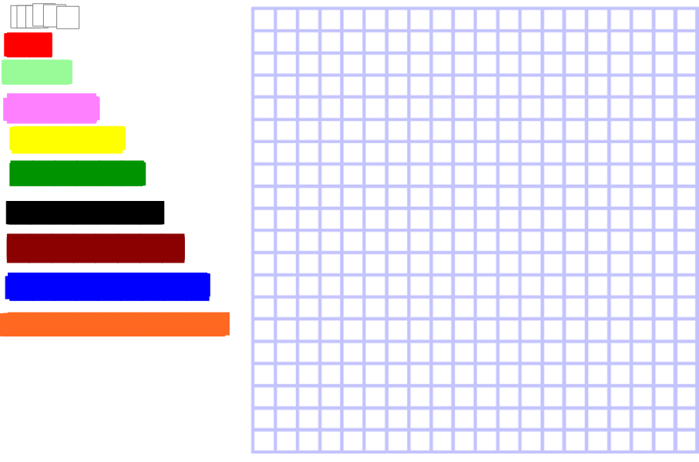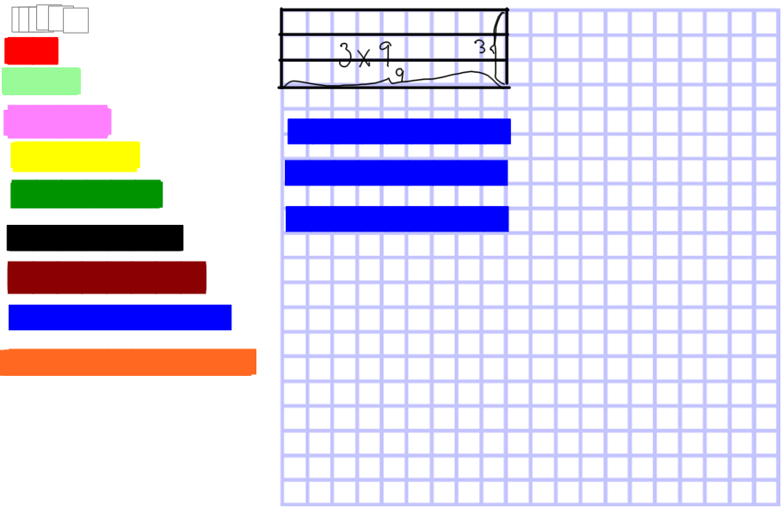

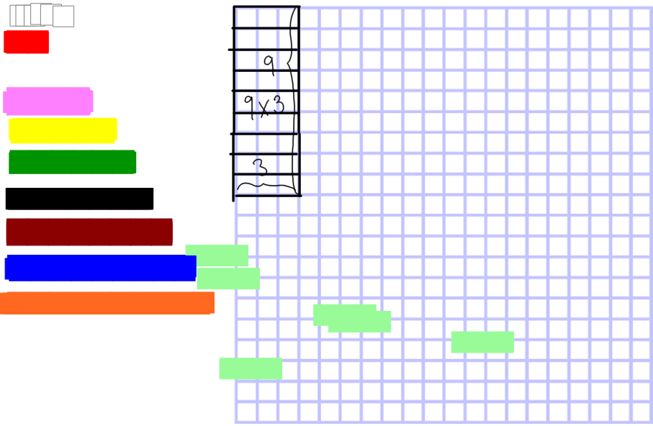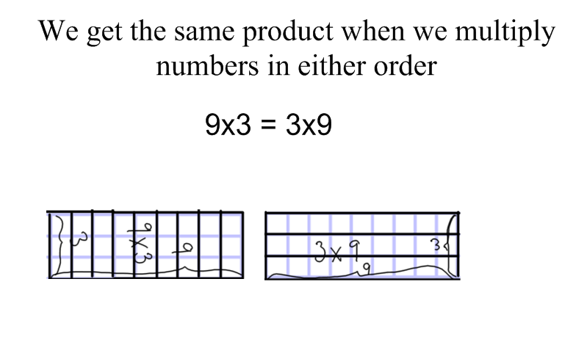

Note: the pages are set up with the same number of virtual Cuisenaire rods as children have in their bags (infinite cloners are not used, so that we can discuss what happens if you don’t have enough rods). “Cutting out” on the SMART board is done by using the Screen Capture tool to take a pict
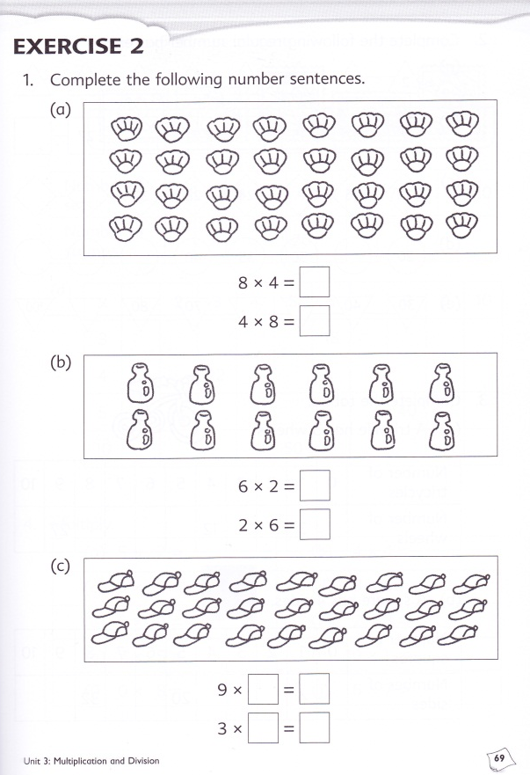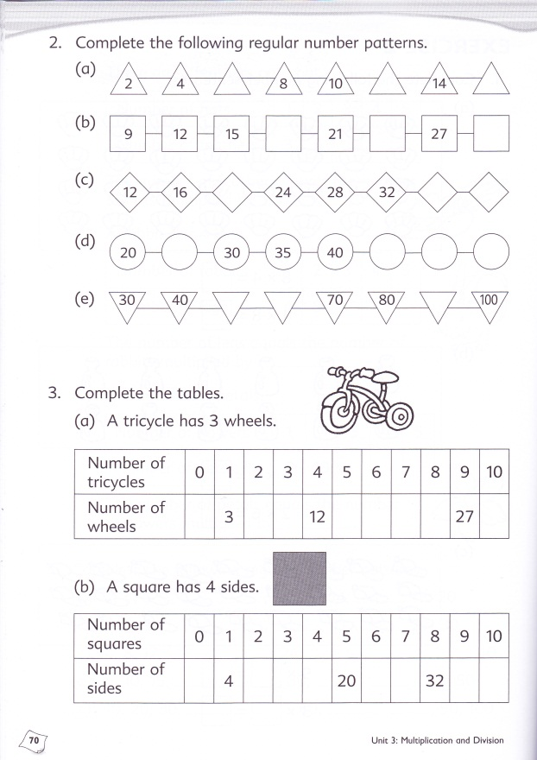

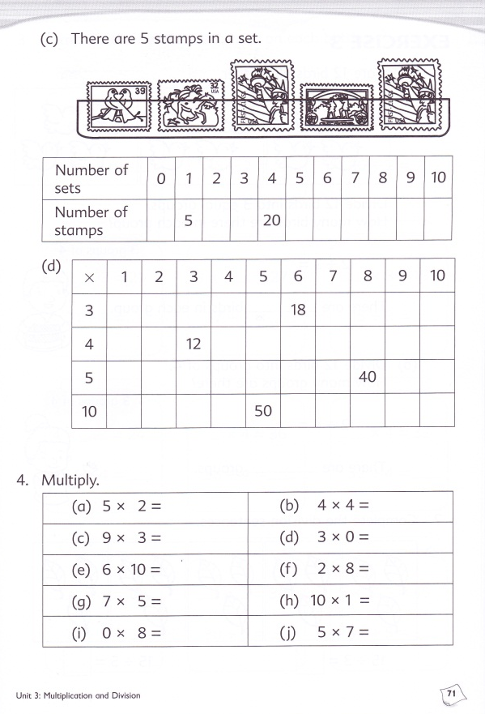

Lesson number/date and section number/name:  Lesson 3, third part of section 1 Looking Back | Materials:  SMART Notebook (or overhead projector slides) with problems and copies of the book pages.  Per pair of students:  - counters (units from base 10 blocks)  - cm grid paper (2 pages)  Per student:  - textbook  - workbook  - pencil  - white board and marker
Big idea: fact families for multiplication and division
Source(s): pg. 72-75

Learning goals: (include relevant standards from CCSS)
Fact families for multiplication and division
Writing division equations from a rectangle picture
Solving division problems (especially measurement division) by direct modeling, skip counting, and fact families
- 3.OA.3. Use multiplication and division within 100 to solve word problems in situations involving equal groups, arrays, and measurement quantities, e.g., by using drawings and equations with a symbol for the unknown number to represent the problem.¹
- 3.OA.4. Determine the unknown whole number in a multiplication or division equation relating three whole numbers. For example, determine the unknown number that makes the equation true in each of the equations 8 × ? = 48, 5 = _ ÷ 3, 6 × 6 = ?
3.OA.6. Understand division as an unknown-factor problem. For example, find 32 ÷ 8 by finding the number that makes 32 when multiplied by 8.
Description (summary):
Students solve a measurement division problem by direct modeling with counters on grid paper:
- There are 5 chairs in each row. There are 20 chairs in all. How many rows are there?
Have children write the division number sentence and the two multiplication number sentences for the picture. On the board, draw a box around the 4’s in the number sentences and erase the 4’s—show that the missing number multiplication problems are the same as the division problem.

Do the same for a similar problem:
- Jan had 12 feet of ribbon. She used 4 feet of ribbon to wrap each package. How many packages could she wrap?
Children solve by counters. Challenge children to show their answer as a rectangle diagram. Have children write the multiplication and division number sentences on their white boards and check.

Have children change the 3’s to empty boxes to show the missing number multiplication problem.

Show a diagram for 5 groups of 4. Ask the multiplication question: how many is 5 groups of 4?
Write the multiplication number sentence.
Ask the division question: Divide 20 into 5 groups, how many are in each group? Write the division number sentence.
Ask the division question: Divide 20 into groups of 4, how many groups? Write the division number sentence.

Give children a division problem: 15÷5= , and ask them to write the missing number multiplication problems that can help us solve it. Repeat with another example.

Show and work together textbook # 10, 11

Walk around and observe while children do Unit 3 Exercise 3 in their workbooks.

Lesson number/date and section number/name:  Lesson 4, fourth part of section 1 Looking Back | Materials:  SMART Notebook (or overhead projector slides) with problems and copies of the book pages.  Per pair of students:  - counters (units from base 10 blocks)  - cm grid paper (2 pages)  Per student:  - textbook  - workbook  - pencil  - white board and marker
Big idea: finding numerical solutions for multiplication and division problems
Source(s): pg. 72-75

Learning goals: (include relevant standards from CCSS)
Fact families for multiplication and division
Multiplying by 0 and 1
Solving division problems (especially measurement division) by direct modeling, skip counting, and fact families
- 3.OA.4. Determine the unknown whole number in a multiplication or division equation relating three whole numbers. For example, determine the unknown number that makes the equation true in each of the equations 8 × ? = 48, 5 = _ ÷ 3, 6 × 6 = ?
3.OA.6. Understand division as an unknown-factor problem. For example, find 32 ÷ 8 by finding the number that makes 32 when multiplied by 8.
Description (summary):

Show and discuss Textbook # 5, 7 and 8. Discuss patterns for multiplying by 0 and 1.

Show and discuss #13. Draw a diagram, and discuss the number sentences.

Show a division problem such as 15÷ 3. Discuss how to write it as a missing number multiplication problem, and how to solve by skip counting and direct modeling.

Show and discuss strategies for #14

Show and discuss strategies for #15

Walk around and observe while children do Unit 3 Exercise 4 in their workbooks.

Lesson number/date and section number/name:  Lesson 5, section 2 More Word Problems | Materials:  SMART Notebook (or overhead projector slides) with problems and copies of the book pages.  - counters (ones from base 10 blocks)  - white boards and markers  - textbook  - workbook  - pencil
Big idea(s): Use bar diagrams to help solve multiplication and partition division word problems

Source(s):
section 3.2
Learning goals: (include relevant standards from CCSS)
Draw diagrams, write number sentences and direct model when needed to solve multiplication and division word problems.

3.OA.3. Use multiplication and division within 100 to solve word problems in situations involving equal groups, arrays, and measurement quantities, e.g., by using drawings and equations with a symbol for the unknown number to represent the problem.
Description (summary):
Give a multiplication problem: [example pg 77—3x9]. Who remembers bar diagrams? Show a bar diagram for the problem. Explain that in a multiplication problem, all of the bars that are end-to-end in the bar have equal length.

Give another multiplication problem [A bee has 6 legs, how many legs do 5 bees have?] Have children show the bar digram on their whiteboard. Have children solve the problem and write the number sentence on their white board. Have children write the commutative law number sentence on their white board.

Give a partition division problem: 4 children shared a plate of 12 cookies. How many cookies did each child get. Show a bar diagram for the problem. Explain that this is a division problem, and in this division problem, all of the bars are the same size, but we don’t know what size that is. We can write this problem as a division number sentence or a missing number multiplication number sentence. Show the number sentences

Give another partition division problem: 3 children shared the cost of a pizza. The pizza cost $15. How much did each child pay? Have children draw the bar diagram on their white board and show. Have the children write the number sentences on their whiteboards. Ask the children to solve the problem. Choose children with different strategies to show how they solved the problems.

Observe while children work the problems in section 2, and workbook exercise 5

Lesson number/date and section number/name:  Lesson 6, review with word problems | Materials:  SMART Notebook (or overhead projector slides) with problems and copies of the book pages.  - counters (ones from base 10 blocks)  - whiteboards and markers  - pencil  - textbook  - workbook  - lined paper
Big idea(s):
review word problems
Source(s):
pg. 80
Learning goals: (include relevant standards from CCSS)
Draw diagrams, write number sentences and direct model when needed to solve multiplication and division word problems.

3.OA.3. Use multiplication and division within 100 to solve word problems in situations involving equal groups, arrays, and measurement quantities, e.g., by using drawings and equations with a symbol for the unknown number to represent the problem.
Description (summary):
Review with personal white boards how to draw bar diagrams and write number sentences for 2 multiplication and 2 division word problems

Observe while children solve problems in workbook section 6

Lesson number/date and section number/name:  Lesson 7, review with word problems | Materials:  SMART Notebook (or overhead projector slides) with problems and copies of the book pages.  - counters (ones from base 10 blocks)  - whiteboards and markers  - pencil  - textbook  - workbook  - lined paper
Big idea(s):
review word problems
Source(s):
pg. 80
Learning goals: (include relevant standards from CCSS)
Draw diagrams, write number sentences and direct model when needed to solve multiplication and division word problems.

3.OA.3. Use multiplication and division within 100 to solve word problems in situations involving equal groups, arrays, and measurement quantities, e.g., by using drawings and equations with a symbol for the unknown number to represent the problem.
Description (summary):
Observe while children solve problems in workbook section 7
Invite children to share how they solved these problems.
Discuss what parts of the problems are multiplication, division, addition and subtraction.

Lesson number/date and section number/name:  Lesson 8, first part of section 3 Multiplying Ones, Tens, Hundreds and Thousands | Materials:  SMART Notebook (or overhead projector slides) with problems and copies of the book pages.  per pair:  - base 10 blocks (30 each of 1’s, 10’s and 100’s)  each:  - whiteboards and markers  - pencil  - textbook  - workbook
Big idea(s):
Multiply 1 digit numbers by tens, hundreds and thousands
Source(s):
pg. 82-86
Learning goals: (include relevant standards from CCSS)

Multiply 1 digit numbers by multiples of 10, 100 and 1000.

3.NBT.3. Multiply one-digit whole numbers by multiples of 10 in the range 10–90 (e.g., 9 × 80, 5 × 60) using strategies based on place value and properties of operations.

4.NBT.5. Multiply a whole number of up to four digits by a one-digit whole number, and multiply two two-digit numbers, using strategies based on place value and the properties of operations. Illustrate and explain the calculation by using equations, rectangular arrays, and/or area models.

Description:
Multiply by hundreds, tens and thousands. Do some problems with base 10 blocks, and some with numbers.
Do example problems with base 10 blocks.
Have children do 4x6, 4x60, 4x600 with base 10 blocks, and show answers on white boards.
Ask children for patterns they noticed. Highlight the 0’s in each problem to show the pattern.
Give #1 problems one at a time as white board problems.
Show and discuss #2

Observe while children work problems from workbook exercise 8

Lesson number/date and section number/name:  Lesson 9, first part of section 3 Multiplying Ones, Tens, Hundreds and Thousands | Materials:  SMART Notebook (or overhead projector slides) with problems and copies of the book pages.  per pair:  - base 10 blocks (30 each of 1’s, 10’s and 100’s)  each:  - whiteboards and markers  - pencil  - textbook  - workbook
Big idea(s):
Multiply 1 digit numbers by tens, hundreds and thousands
Source(s):
pg. 82-86
Learning goals: (include relevant standards from CCSS)

Multiply 1 digit numbers by multiples of 10, 100 and 1000.
Multiply a 2 digit number by a 1 digit number

3.NBT.3. Multiply one-digit whole numbers by multiples of 10 in the range 10–90 (e.g., 9 × 80, 5 × 60) using strategies based on place value and properties of operations.

4.NBT.5. Multiply a whole number of up to four digits by a one-digit whole number, and multiply two two-digit numbers, using strategies based on place value and the properties of operations. Illustrate and explain the calculation by using equations, rectangular arrays, and/or area models.

Description:
Warm up with problems from #3 as white board problems.
Give 10x3 and 3x3 as white board problems. Ask what 13x3 should be. Show how to write the answer in standard (vertical) form.
Give 20x4 and 6x4 as white board problems. Ask what 26x4 should be. Show how to write the solution in standard (vertical) form.
Do problems with the class: 45x3; 36x3
Observe while children work workbook exercise 9

Lesson number/date and section number/name:  Lesson 10, second part of section 3 Multiplying Ones, Tens, Hundreds and Thousands | Materials:  SMART Notebook (or overhead projector slides) with problems and copies of the book pages.  - whiteboards and markers  - pencil  - textbook  - workbook
Big idea(s): multiply 1 digit by 2 digit numbers.

Source(s):
pgs 86-89
Learning goals: (include relevant standards from CCSS)

Multiply 2 and 3 digit numbers by a 1 digit number

4.NBT.5. Multiply a whole number of up to four digits by a one-digit whole number, and multiply two two-digit numbers, using strategies based on place value and the properties of operations. Illustrate and explain the calculation by using equations, rectangular arrays, and/or area models.

Description:
On whiteboards work through 2 example problems.
Observe while children work exercise 10

Lesson number/date and section number/name:  Lesson 11, second part of section 3 Multiplying Ones, Tens, Hundreds and Thousands | Materials:  SMART Notebook (or overhead projector slides) with problems and copies of the book pages.  - whiteboards and markers  - pencil  - textbook  - workbook
Big idea(s): multiply 1 digit by 2 and 3 digit numbers.

Source(s):
pgs 86-89
Learning goals: (include relevant standards from CCSS)

Multiply 2 and 3 digit numbers by a 1 digit number

4.NBT.5. Multiply a whole number of up to four digits by a one-digit whole number, and multiply two two-digit numbers, using strategies based on place value and the properties of operations. Illustrate and explain the calculation by using equations, rectangular arrays, and/or area models.

Description:
On whiteboards work through 2 example problems.
Observe while children work Exercise 11

Lesson number/date and section number/name:  Lesson 12, second part of section 3 Multiplying Ones, Tens, Hundreds and Thousands | Materials:  SMART Notebook (or overhead projector slides) with problems and copies of the book pages.  - whiteboards and markers  - pencil  - textbook  - workbook
Big idea(s): multiply 1 digit by 2 and 3 digit numbers.

Source(s):
pgs 86-89
Learning goals: (include relevant standards from CCSS)

Multiply 3 and 4 digit numbers by a 1 digit number

4.NBT.5. Multiply a whole number of up to four digits by a one-digit whole number, and multiply two two-digit numbers, using strategies based on place value and the properties of operations. Illustrate and explain the calculation by using equations, rectangular arrays, and/or area models.

Description:
On whiteboards work through 2 example problems.
Observe while children work Exercise 12

Lesson number/date and section number/name:  Lesson 13, first part of section 4 Quotient and Remainder | Materials:  SMART Notebook (or overhead projector slides) with problems and copies of the book pages.  per pair:  - base 10 blocks (30 1’s, and 10 10’s)  each:  - whiteboards and markers  - pencil  - textbook  - workbook
Big idea(s):
division with remainders
Source(s):
pg. 94-99
Learning goals: (include relevant standards from CCSS)
Divide 2 digit numbers by single digit numbers with remainders using materials and division using the long division algorithm
3.OA.7.Fluently multiply and divide within 100, using strategies such as the relationship between multiplication and division (e.g., knowing that 8 × 5 = 40, one knows 40 ÷ 5 = 8) or properties of operations. By the end of Grade 3, know from memory all products of two one-digit numbers.

4.NBT.6. Find whole-number quotients and remainders with up to four-digit dividends and one-digit divisors, using strategies based on place value, the properties of operations, and/or the relationship between multiplication and division. Illustrate and explain the calculation by using equations, rectangular arrays, and/or area models.
Description:
Ask the example word problem. Children solve by direct modeling and share. Show how to write the answer with the long division algorithm.

Work 1-5 together as a class using base 10 blocks and the long division algorithm. Discuss # 6.
Work #7 and 8 as a class using only the long division algorithm.
Observe while children work exercise 13 in the workbook.

Lesson number/date and section number/name:  Lesson 14, second part of section 4 Quotient and Remainder | Materials:  SMART Notebook (or overhead projector slides) with problems and copies of the book pages.  per pair:  - base 10 blocks (30 1’s, and 10 10’s)  each:  - whiteboards and markers  - pencil  - textbook  - workbook
Big idea(s):
division with remainders
Source(s):
pg. 94-99
Learning goals: (include relevant standards from CCSS)
divide 2 digit numbers by single digit numbers with remainders using the long division algorithm and in word problem contexts.
3.OA.7.Fluently multiply and divide within 100, using strategies such as the relationship between multiplication and division (e.g., knowing that 8 × 5 = 40, one knows 40 ÷ 5 = 8) or properties of operations. By the end of Grade 3, know from memory all products of two one-digit numbers.

4.NBT.6. Find whole-number quotients and remainders with up to four-digit dividends and one-digit divisors, using strategies based on place value, the properties of operations, and/or the relationship between multiplication and division. Illustrate and explain the calculation by using equations, rectangular arrays, and/or area models.
Description:
Review by doing problems 10 and 11 as partners and sharing as a class.
Observe while children do workbook exercise 14

Lesson number/date and section number/name:  Lesson 15, section 5 Dividing Hundreds, Tens and Ones | Materials:  SMART Notebook (or overhead projector slides) with problems and copies of the book pages.  per pair:  - base 10 blocks (30 1’s and 10’s, 10 100’s)  each:  - whiteboards and markers  - pencil  - textbook  - workbook
Big idea(s):
Dividing 3 digit numbers by 1 digit numbers
Source(s):
section 5
Learning goals: (include relevant standards from CCSS)
Divide 3 digit numbers by 1 digit numbers using materials and the long division algorithm and with word problems.

4.NBT.6. Find whole-number quotients and remainders with up to four-digit dividends and one-digit divisors, using strategies based on place value, the properties of operations, and/or the relationship between multiplication and division. Illustrate and explain the calculation by using equations, rectangular arrays, and/or area models.
Description: Work the examples with base 10 blocks and the long division algorithm as a class.
Work 1-4 using manipulatives and long division as a class.
Observe as children work exercise 15 in the workbook.

