**Multiplication properties and facts assignment** name:

1. Draw several diagrams for 3 × 5

2. Explain why the commutative property isn't obvious to a second grader (you may wish to choose a numerical example to illustrate your explanation).

3. a. Explain, using an appropriate, well labelled diagram and sentences, why it works and makes sense that 

b. What is the name of this property

4. a. Explain, using an appropriate, well labelled diagram and sentences, why it makes sense that 

b. What is the name of this property

5. Show how to solve 

a. using the strategy described for 4’s

b. using the strategy described for 6’s

6. Show how to solve 7 × 9

a. using a strategy for 9’s

b. by breaking down 7 into 5 and 2

7. Once upon a time, I was working with 3 children on a multiplication problem, and this problem had a lot of 5’s in it. We were using manipulatives that look like this:

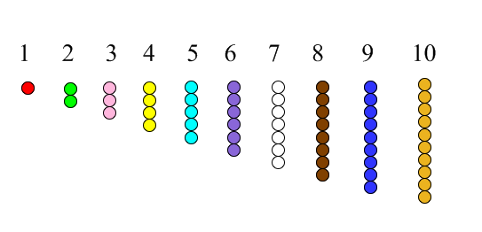

So, to show 5 × 4, usually you would represent it this way (4 bars that are each 5 long):

But we had run out of 5’s, so I asked the children what to do. These are the 3 ways they suggested we could use the manipulatives to show 5 × 4:

A. B. C.

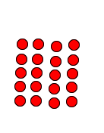 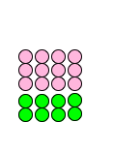 

Write me your best analysis of each of these 3 ways of showing 5 × 4.

a. What was child A thinking when he did what he did? (Does his thinking relate to either the commutative or distributive law, or is it a strategy that uses addition or counting or…?)

b. What was child B thinking when she did what she did? (Does her thinking relate to either the commutative or distributive law, or is it a strategy that uses addition or counting or…?)

c. What was child C thinking when she did what she did? (Does her thinking relate to either the commutative or distributive law, or is it a strategy that uses addition or counting or…?)