Area and Perimeter Homework:

1. Show how to find the area by breaking down the shape into rectangles:
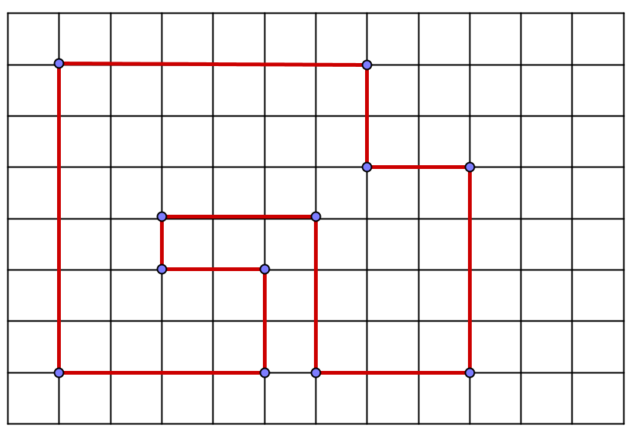
2. Show how to illustrate and explain this example of the distributive law using rectangles/a rectangular grid.
4×(5 + 2) = 4×5 + 4×2

3. Find the perimeter of each shape:
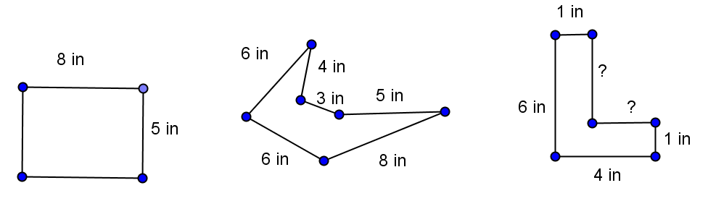

4. Find the missing side lengths:
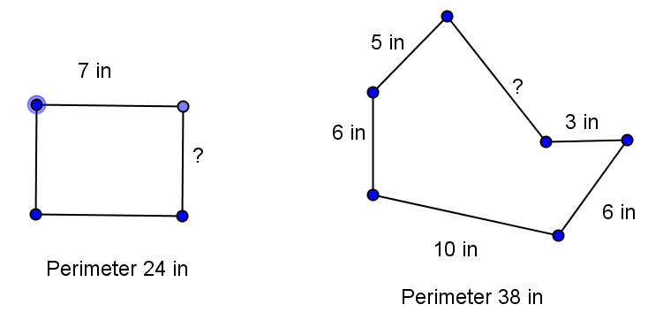

5. Find and draw 3 rectangles that have the same area and different perimeters.

6. Find and draw 3 rectangles that have the same perimeter, and different areas.

7. These two rectangles have the same perimeter. Which do you think will have a larger area and why?
