Van Hiele levels and geometric attributes homework
1. Draw this pentagon in a different orientation:
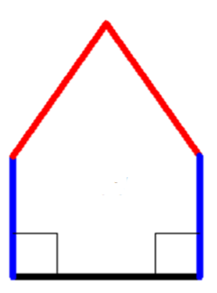

2. Tell 4 geometric attributes that this quadrilateral has

3. Tell 2 non-geometric attributes that this quadrilateral has:
4. Tell 3 geometric properties that all rhombi have
(note: an attribute that all rhombi have could be called a defining attribute, even if it doesn’t usually appear in the definition)

5. Draw a quadrilateral that has exactly 2 right angles (2 and only 2) | 6. Draw a pentagon that has (at least) 2 acute angles

7. Give an example of how a level 1 (Analysis) understanding of triangles is different from a level 0 (Visual) understanding of triangles.

