1. Explain in words the steps in the standard algorithm for
a. 263 + 182

There are 2 units and 3 units, so there are 5 units together. We write 5 in the one’s place of the answer.

There are 6 tens and 8 tens, which is 14 tens. 10 tens is 100, so we trade 10 tens for 100 (or rename 10 tens as 100). Write 4 in the tens place in the answer. Write 1 in the hundreds place above the addends because we still need to add it in.

There are 2 hundreds from 263, 1 hundred from 182 and 1 hundred that we got from adding the tens, so there are 4 hundred in all. Write 4 in the hundreds place of the answer.

b. 328 – 192

We start with 328, and we’re going to take away 192. First we take away 2. We can take away 2 ones from the 8 ones in 328, leaving 6 ones. Write 6 in the ones place of the answer.

Next we need to take away 9 tens. There are only 2 tens in 328, so we trade 1 hundred for 10 tens in 328. This changes it so there are 2 hundreds and 12 tens, so we cross off 3 in the hundreds place and write in 2, and we cross off 2 in the tens place and write in 12.

Now we can take away 9 tens from 12 tens, which leaves 3 tens. We write 3 in the tens place of the answer.

We take 1 hundred away from the 2 hundred, which leaves us with 1 hundred. We write 1 in the hundreds place of the answer.

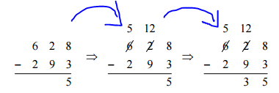
(I don’t have enough tens to take away 9 tens, so...) I trade 100 for 10 tens. (I write down the result:) Then I have 5 hundreds and 12 tens.
12 tens minus 9 tens is 3 tens
Take away 9 tens from 12 tens to get 3 tens.

2. Show how to compute 385 + 279 using the expanded algorithm

3. Show how to compute 623 - 184 using the expanded algorithm (breaking into place values and exchanging)

4. Given examples of student work
a. Describe the process/algorithm the student is following to get their answers.
b. Decide whether that process leads to consistently correct answers (alternate algorithm) or consistently incorrect answers (error pattern).
c. If it is an error pattern, determine what the key understanding is that is causing problems for the student, and explain how you might help a student who is making that error.
Examples:
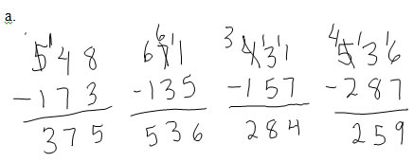
This student is getting correct answers if they only need to trade once, but when they need to trade into both the ones and the tens column, they are decreasing the 100s place by 1 hundred, but increasing both the tens and the ones place (by 10 tens and 10 ones), which isn’t an equal trade.
I think doing problems using the expanded algorithms or manipulatives might be helpful for this student because they both show more detail about what’s going on when you trade. Acting it out using money as a manipulative might also help them understand the importance of equal trades.
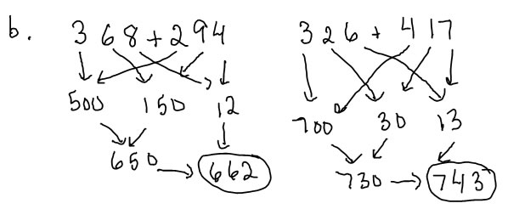
This child is adding each place value separately and then putting them together. It’s very similar to the expanded algorithm, but using arrows instead of columns to track the place value sums.

5. Explain why subtracting across a 0 (as in 403-128) is difficult for children.

It’s difficult because children have been taught to start in the ones column and make a trade so they can subtract ones first. If there’s a 0 in the tens column, then you can’t make a trade between the tens and ones column first—you have to make a trade with the hundreds and tens column before you can make the tens and ones trade, which is a longer and less familiar process.

6. Identify a multiplication or division word problem as being multiplication, partitive division or measurement division, draw a corresponding bar diagram, and write a division and/or multiplication number sentence that shows the relationship. [There are practice problems with solutions in the Nov 9-14 multiplication and division lesson.]

7. Describe a typical way that a child would direct model to solve a multiplication problem, a measurement division problem and a partitive division problem. [There are practice problems with solutions in the Nov 9-14 multiplication and division lesson.]

8. Write a multiplication, a measurement division and a partitive division problem (eg. Write a measurement division problem for 48 ÷ 6) [Many correct answers. You may find the practice problems and solutions in the Nov 9-14 multiplication and division lesson helpful]. An example of a measurement division problem for 48 ÷ 6 is: There are 48 strawberries in the basket. If I put 6 in each bowl, how many bowls can I fill?

9. Solve a 2-step word problem, showing the solution process with bar diagrams, equations and sentences.
a. Kyle has 36 Lego mini-figures. He has 4 times as many mini-figures as Larry. How many more mini-figures does he have than Larry?

36

Kyle

Larry

?
36 ÷ 4 =? = 9 4 x ? = 9

36
Kyle

Larry ?
9

36 – 9 =? =27

9 + ? =36 ?=27
He has 27 more mini-figures than Larry.

b. Ms Smith has 40 erasers. She has 12 more pencils than she has erasers. If she puts 4 pencils in each box, how many boxes can she fill?

Step 1:
?
Pencils
Erasers
40 12
She has 40 + 12 = ? pencils

40 + 12 = 52

Step 2:
52

...?...
4
4

52 ÷ 4 = ? 4 × ? = 52
?=13. She can fill 13 boxes.

c. A pencil costs $.25 and a notebook costs $.60. How much does it cost to buy notebooks and pencils for each of 14 children?

You can do this in 3 steps: cost for 14 notebooks, cost for 14 pencils, total cost
or 2 steps: total cost per child. total cost for 14 children. I will do the second:
$.60
$.25

?
$.25 + $.60 = ?
$.25 + $.60 = $.85

$.85

?
$.85 × 14 = ?
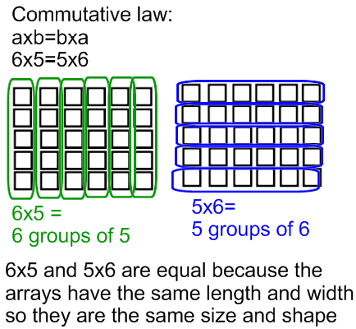
(8.50+1.70+1.70=11.90)
It costs $11.90 for 14 children.

For the second diagram, I would also accept:

... 14 sets ...
$.85
$.85

?

10. a. Explain, using an appropriate, well labelled diagram and sentences, why it works and makes sense that 4×6 = 6×4
Draw a diagram and write an (in words) explanation that shows why the commutative law of multiplication makes sense (your sentences should match your picture). Here are two versions you might want to use
Version 1:  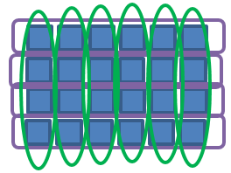  4 × 6 = 4 groups of 6  6 × 4 = 6 groups of 4  6 groups of 4 and 4 groups of 6 are two ways of grouping and counting the same squares, so they are equal | version 2:  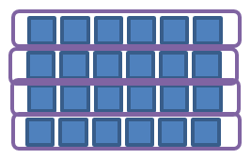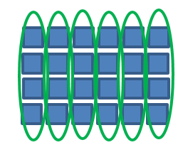  6 × 4 = 6 groups of 4  4 × 6 = 4 groups of 6  6 groups of 4 and 4 groups of 6 are equal because the arrays have the same length and width, and so they are the same size and shape.
b. What is the name of this property (spelling counts) Commutative law
11. a. Explain, using an appropriate, well labelled diagram and sentences, why it makes sense that 3×7 = 3×5+3×2
There are 3 correct explanations that I can think of:
version 1:  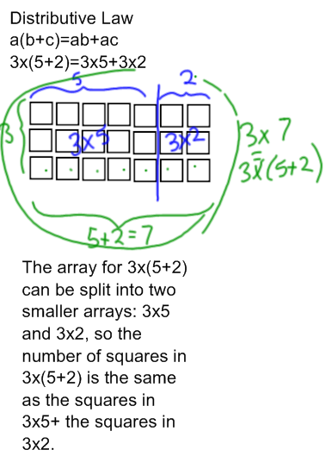 | version 2:  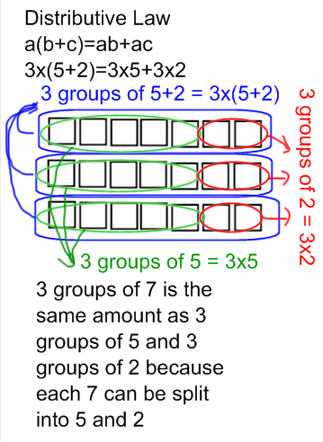 | version 3:  . 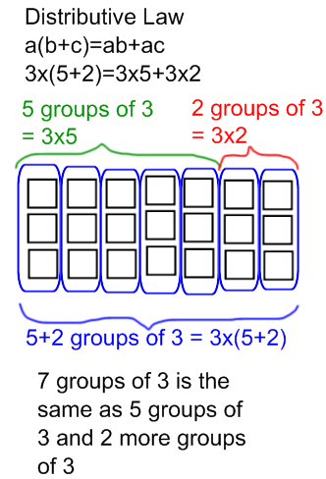
b. What is the name of this property (spelling counts) Distributive law

12. Explain why the commutative property isn't obvious to a second grader (you may wish to choose a numerical example to illustrate your explanation).

They are thinking of multiplication as repeated addition. When you’re adding 3+3+3+3+3, you have a different number of sets, and a different amount in each set than when you’re adding 5+5+5, so it’s kind of surprising that you get the same answer to both problems.

13. Know and be able to show how to use some multiplication fact strategies, in particular:
a. the double twice strategy (for 4x)
b. add on to a known fact (distributive law) strategy (for 3's and 6's)
c. compare to x10 (for 9’s)

14. Sketch what 256 × 5 would look like when built with manipulatives of your choice.
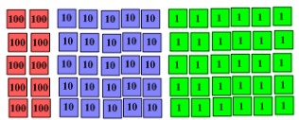

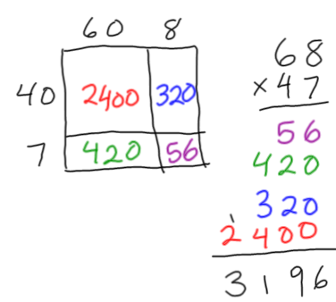
15. For the product 68 × 47
a. Sketch a by-hand (non-proportional) array diagram for the product.
b. Write out the solution using the expanded algorithm.
c. Indicate how the partial products in the expanded algorithm correspond to the parts of the diagram in a. (color code, draw arrows, label things...something like that)

16. For the product 38 × 26
a. Sketch a proportional array diagram for the product on the grid below.
b. Write out the solution using the expanded algorithm.
c. Indicate how the partial products in the expanded algorithm correspond to the parts of the diagram in a. (color code, draw arrows, label things...something like that)
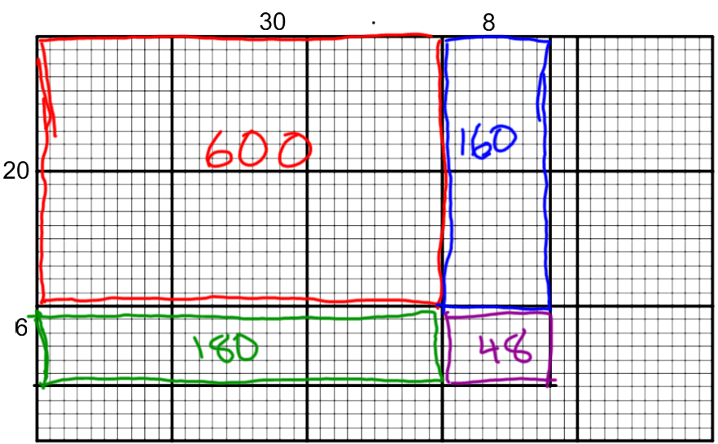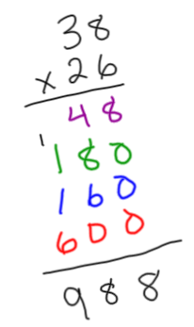
19. Solve a word problem with a remainder. Explain how the remainder affects the answer to the question. [See the practice problems and solutions to the division with remainders lesson]

