1. Explain in words the steps in the standard algorithm for

a.  263 + 182

b. 328 – 192

2. Show how to compute 385 + 279 using the expanded algorithm

3. Show how to compute 623 - 184 using the expanded algorithm (breaking into place values and exchanging)

4. Given examples of student work

a. Describe the process/algorithm the student is following to get their answers.

b. Decide whether that process leads to consistently correct answers (alternate algorithm) or consistently incorrect answers (error pattern).

c. If it is an error pattern, determine what the key understanding is that is causing problems for the student, and explain how you might help a student who is making that error.

Examples:

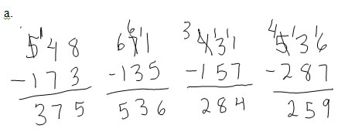

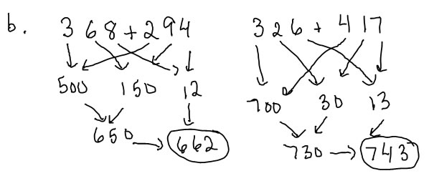

5. Explain why subtracting across a 0 (as in 403-128) is difficult for children.

6. Identify a multiplication or division word problem as being multiplication, partitive division or measurement division, draw a corresponding bar diagram, and write a division and/or multiplication number sentence that shows the relationship.

7. Describe a typical way that a child would direct model to solve a multiplication problem, a measurement division problem and a partitive division problem.

8. Write a multiplication, a measurement division and a partitive division problem (eg. Write a measurement division problem for 48 ÷ 6)

9. Solve a 2-step word problem, showing the solution process with bar diagrams, equations and sentences.

a. Kyle has 36 Lego mini-figures. He has 4 times as many mini-figures as Larry. How many more mini-figures does he have than Larry?

b. Ms Smith has 40 erasers. She has 12 more pencils than she has erasers. If she puts 4 pencils in each box, how many boxes can she fill?

c. A pencil costs $.25 and a notebook costs $.60. How much does it cost to buy notebooks and pencils for each of 14 children?

10. a. Explain, using an appropriate, well labelled diagram and sentences, why it works and makes sense that 4×6 = 6×4

b. What is the name of this property (spelling counts)

11. a. Explain, using an appropriate, well labelled diagram and sentences, why it makes sense that 3×7 = 3×5+3×2  
b. What is the name of this property (spelling counts)

12. Explain why the commutative property isn't obvious to a second grader (you may wish to choose a numerical example to illustrate your explanation).

13. Know and be able to show how to use some multiplication fact strategies, in particular:

a. the double twice strategy (for 4x)

b. add on to a known fact (distributive law) strategy (for 3's and 6's)

c. compare to x10 (for 9’s)

14. Sketch what 256 × 5 would look like when built with manipulatives of your choice.

15. For the product 68 × 47

a. Sketch a by-hand (non-proportional) array diagram for the product.

b. Write out the solution using the expanded algorithm.

c. Indicate how the partial products in the expanded algorithm correspond to the parts of the diagram in a. (color code, draw arrows, label things...something like that)

16. For the product 38 × 26

a. Sketch a proportional array diagram for the product on the grid below.

b. Write out the solution using the expanded algorithm.

c. Indicate how the partial products in the expanded algorithm correspond to the parts of the diagram in a. (color code, draw arrows, label things...something like that)



19. Solve a word problem with a remainder. Explain how the remainder affects the answer to the question.