Fluency with small numbers assignment. name:
Note: this worksheet is formatted for you to type into and copy graphics into. If you wish to print and handwrite your answers, you should first insert a bunch of space after each question so you will have room to write
1. What are some decompositions a child might suggest for this 10-frame? List at least two.
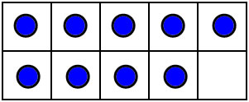

2. What are some decompositions a child might suggest for this dot pattern? List at least two.
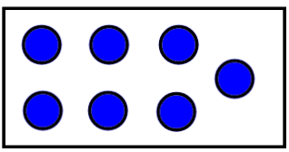

3. Draw or describe 4 ways of representing the number 7 so that it can be readily recognized without counting (these should each be conceptual subitizing patterns).

4. Write 5 addition or subtraction questions you could ask and answer about the number relationship shown by these Cuisenaire rods. (These should be a variety of ways of asking the same 1 or 2 questions). (Note: there’s an example of this type of problem in #4 the practice problems and answers. Please go look at that if you don’t understand what this question is asking)

5. Write 6 number sentences that express the number relationship shown by the Cuisenaire rods in #4 in slightly different ways. (Note: there’s an example of this type of problem in #5 of the practice problems and answers. Please go look at that if you don’t understand what this question is asking)

6. What does it mean to decompose the number 6?

