Growing patterns:

1. Start by filling out the worksheet for the fish pattern from the readings:

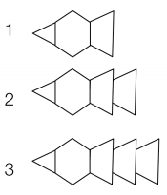  4  5 |  |  | How many of each block would you need to build the fish on its 10th birthday?  Sketch what the fish will look like on its 10th birthday?
Birthday | Which blocks? How many?  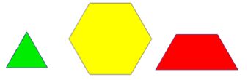 | Total number of blocks

2. Make a growing pattern. Show the first 3 steps and describe how it grows.

3. This is a growing pattern made out of pattern blocks. My pattern is for a fir tree growing
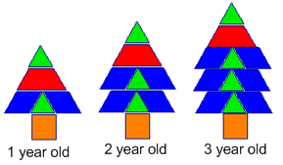
Make a table for this tree and explain how the pattern grows.

4. This is a growing pattern made out of pattern blocks. It shows a prickly caterpillar
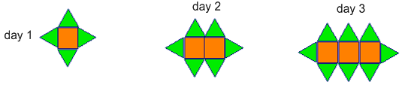
a. Sketch what a 4 day caterpillar will look like.

b. If the caterpillar has 20 squares, how many triangles will it have?

c. How do you know?

d. If the caterpillar has 14 triangles, how many squares will it have??

e. How do you know?

f. Will the caterpillar ever have 11 triangles?

g. How do you know?

5. Make a repeating pattern with pattern blocks, and write questions for a problem similar to the train car problem.

Train car problem
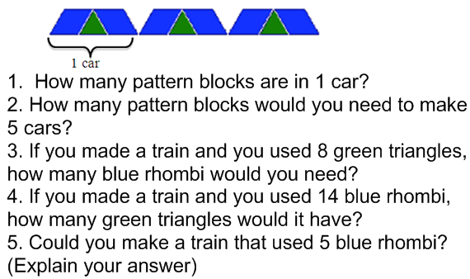

6. Find and explain a multiplicative relationship in one of the patterns above.

