Practice problems for test:



1. Write the matrix multiplication you would do to perform the row operation where you switch Row 1 and Row 2 in matrix A (write the matrix, and show whether you would multiply it on the left or on the right of A)

2. Write the matrix multiplication you would do to perform the row operation in matrix A where you replace Row 3 by 2 \* Row 1 + Row 3 (write the matrix, and show whether you would multiply it on the left or on the right of A)

3. Write the matrix multiplication you would do to perform the row operation where switch Column 1 and Column 2 in matrix A (write the matrix, and show whether you would multiply it on the left or on the right of A)

4. Write the matrix multiplication you would do to multiply the first Column of A by 3.

5. Show how to find by doing row operations/Gaussian Elimination.

6. Find the inverse matrix of A (using the method of your choice)

7. Explain why you can (or prove that you can) do Gaussian elimination to find an inverse for a 2x2 matrix. You may use a specific example in your explanation, but your explanation should be generalizable to explain why it works for any 2x2 matrix.

8. Give an example of a matrix where it would be faster to use Gaussian Elimination to find the determinant than it would be if you used expansion to find the determinant.

9. Give an example of a system of equations where you would prefer to use Cramer’s Rule than use Gaussian Elimination (because it would be faster/easier). Explain your choice.

10. In the system of equations below, if you make a linear combination of the two equations, what kind of equation will you get? How will the graph of the linear combination be related to the graphs of the original equations? Explain how you know.



11. Prove that you can get every line through (1,2) by making linear combinations of



12. Here are some sets of vectors in . For each set tell whether it is independent, and whether it spans .

a. {(1, 1, 0), (2, 2, 0)}

b. {(1, 1, 0), (0, 1, 1)}

c. {(1, 1, 0), (0, 1, 1), (1, 2, 1), (1, 0, -1)}

d. {(1, 1, 0), (1, 2, 1), (0, 1, 1), (0, 1, 0)}

e. {(1, 1, 0), (1, 2, 1), (0, 1, 0)}

f. {(1, 1, 0), (1, 2, 1), (0, 1, 1)}

13. Here are some sets of vectors in . For each set tell whether it is independent, and whether it spans .

a. {(1, 2, 3, 4), (1, 1, 0, 0), (1, 0, 0, 1)}

b. {(1, 2, 3, 4), (1, -1, 3, 5), (1, 5, 3, 3)}

c. {(1, 2, 3, 4), (1, 0, 1, 2), (2, 1, 1, 0), (2, 3, 3, 2), (3, 4, 3, 0)}

d. {(1, 2, 3, 4), (1, 0, 1, 2), (2, 1, 1, 0), (1, 2, 0, 1), (1, 1, 0, 0)}

e. {(1, 2, 3, 4), (1, 0, 1, 2), (2, 1, 1, 0), (1, 2, 0, 1)}

f. {(1, 2, 3, 4), (5, 4, 2, 1), (2, 1, 1, 0), (1, 2, 0, 1)}

Note 1: you can put these vectors into a matrix in two ways: as rows or as columns. Then you can row reduce (or get your calculator to row reduce): what does the reduced form tell you? Do you prefer working with the vectors as rows or as columns?

Note 2: I on purpose gave you easier examples in #12 (ones you can probably figure out without row reducing). Can you use those as examples to help you make sense of #13?

14. The reduced row echelon form of a matrix B is:



a. Each of the 5 rows of the matrix are vectors in . Are these vectors linearly independent? How do you know?

b. Do these vectors span ? How do you know?

c. Each of the 6 columns of the matrix are vectors in . Are these vectors linearly independent? How do you know?

d. Do these vectors span ? How do you know?

15. The reduced row echelon form of a matrix C is:



a. Each of the 5 rows of the matrix are vectors in . Are these vectors linearly independent? How do you know?

b. Do these vectors span ? How do you know?

c. Each of the 6 columns of the matrix are vectors in . Are these vectors linearly independent? How do you know?

d. Do these vectors span ? How do you know?

16. The reduced row echelon form of a matrix D is:



a. The four column vectors of D do not span . What about the reduced form of the matrix tells you that?

b. The four column vectors of D are not linearly independent. If you were going to drop one of the column vectors from the list because it is “extra” (dependent on one or more of the others) which one or ones could you eliminate? Why?

c. Does this reduced row echelon form say that the first vector is 3 times the fourth vector? If not, what does it say?

17. Tell a basis for  that does not include any of ,  or .

18. Explain why matrix multiplication is defined in the way that it is.

19. The set is a basis for .

a. How do we know it is a basis?

b. Represent the vector <1,1> as a linear combination of  and .

c. Represent the vector <1,0> as a linear combination of  and .

d. Represent the vector <0,1> as a linear combination of  and .

e. Write the matrix form of the linear transformation that maps <1,0> to  and <0,1> to .

f. Write the matrix form of the inverse transformation.

20. Write the matrix form of the linear transformation that maps <1,0,0> to <1,2,5>, and <0,1,0> to <-1, 1, 0>, and <0,0,1> to <2,1,1>.

21. Write the matrix form of the linear transformation that maps <1,0> to <2,1> and <0,1> to <-4,-2>. Does this transformation have an inverse function? If so, find the invers. If not, why not?

22. The linear transformation *f* maps <1,0> to  and maps <0,1> to .

Draw and label:

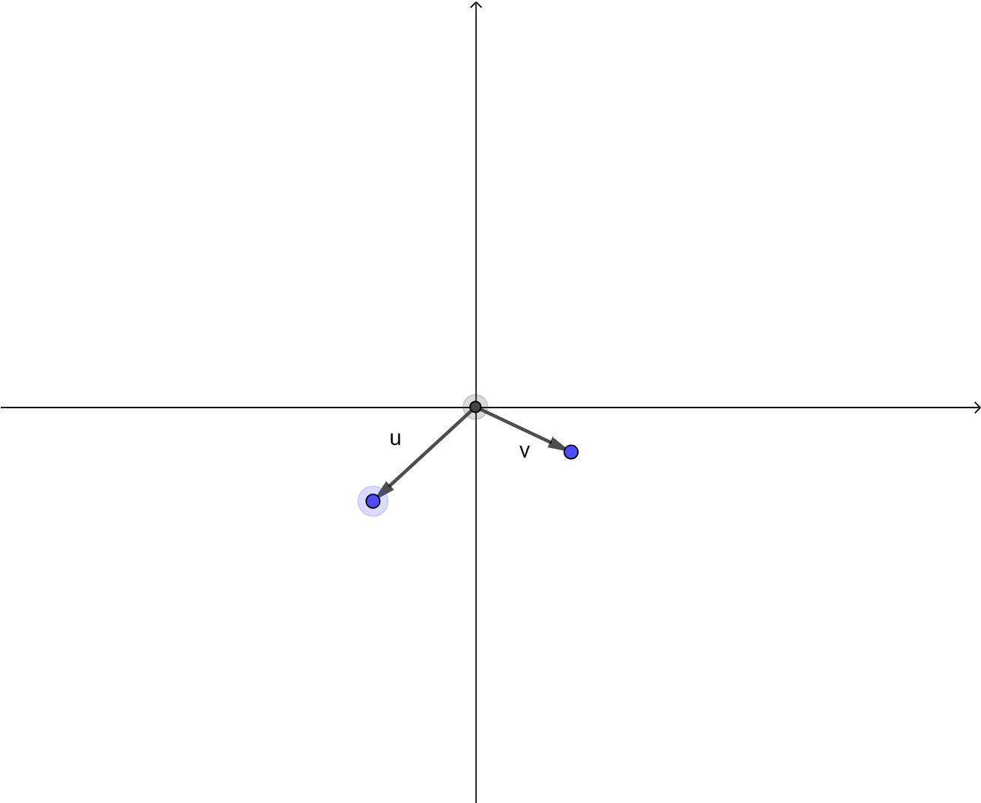a. 

b. 

c. 

d. 

e. 

23. Explain in words how to interpret the dot product of two vectors in terms of projections.

24. Find the projection of <2,3> onto 

25. Find the projection of <-1,3> onto <1,2>

26. Find the projection of <1, 2, 3> onto <1,0,1>

Problems that might be added after Monday’s class:

27. Explain how to use a dot product to find the area of a triangle with vertices at (0,0), (2, 1), (3, -2)

28. Use matrices to find the least squares best fit line for the data values: (2, 4), (3, 5), (4, 7), (5, 9)

29. Use matrices to find the least squares best fit quadratic equation for the data values:

(2, 4), (3, 5), (4, 7), (5, 9)

30. Explain how to think about a least squares fit question using linear algebra, and what it has to do with projections.

31. Explain what each of the steps in the linear algebra least squares best fit algorithm do.