Math 436 Ch 11 homework

Alternate Geometries:

Bolyai, Lobachevsky and Gauss (hyperbolic geometry)

**Hyperbolic and Euclidean lines fact #1**

From these agreed upon axioms or assumptions:

1. Given any two points there is exactly one straight line that contains them
2. Angles and distances can be measured and duplicated
3. Triangles that have congruent 2 sides and the angle between them (SAS) are congruent (the other side and angles are also congruent)

Euclid proved that

1. If you have a pair of lines and a transversal with alternate interior angles being equal, then the lines have to be parallel.

This is without the parallel postulate, and it is true in the Euclidean plane and in the Poincare disk Hyperbolic plane

 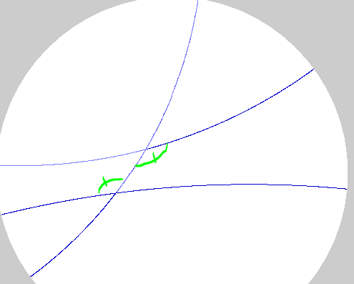

In Euclidean geometry, with the Euclidean parallel postulate, it’s possible to prove that every pair of parallel lines and transversal has this same property (congruent alternate interior angles), but in Hyperbolic geometry, there are parallel lines and transversals where the alternate interior angles are different.

**Euclidean geometry**: Add in the assumption/axiom:

1. The sum of angles in any triangle is 180°.

1. In this triangle  , consider the line  that includes side .

* We can use II to make a line  such that the alternate interior angles shown in figure 1 are equal. Theorem IV tells us that  is parallel to .
* We can also use II to make a line  such that the alternate interior angles shown in figure 2 are equal. Theorem IV tells us that  is parallel to .

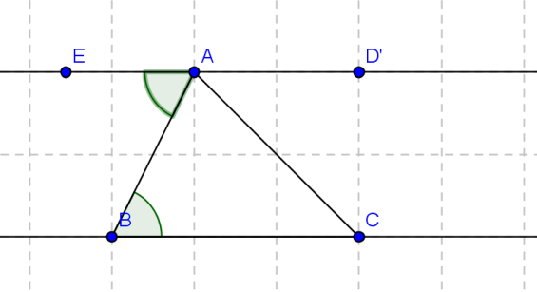 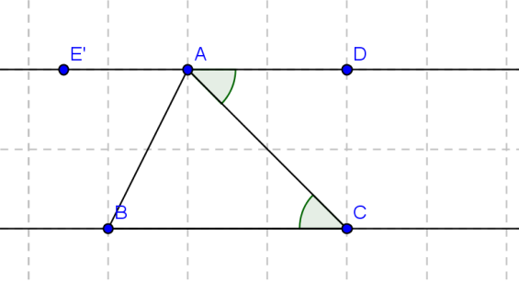



figure 1 figure 2

Use V to prove that the angles  ,  and  add up to . If you can prove that, it means that *E, A* and *D* are all on the same line and = (5 pts)

**Hyperbolic Geometry:** Instead of V, add in the assumption:

Vʹ. The sum of angles in any triangle is strictly less than 180°.

2. In this triangle  , consider the line  that includes side .

* We can use II to make a line  such that the alternate interior angles shown in figure 3 are equal. Theorem IV tells us that  is parallel to .
* We can also use II to make a line  such that the alternate interior angles shown in figure 4 are equal. Theorem IV tells us that  is parallel to .

 



figure 3 figure 4

Use Vʹ to prove that the angles  ,  and  do not add up to . If you can prove that, it means that *E, A* and *D* are not all on the same line and ≠. (5 pts)

**More Hyperbolic plane:**

3. Using the applet NonEuclid: <http://www.cs.unm.edu/~joel/NonEuclid/NonEuclid.html>

a. Draw a triangle, and measure the angles. Print/copy in the triangle and the angle sum. Find the difference between 180˚ and the angle sum.

b. Cut the triangle into two smaller triangles with a line segment from one vertex to the opposite side. Find the angle sums of the two smaller triangles, and print/copy in the triangles and the angle sums. Find the difference between 180˚ and the angle sum for each triangle.

c. How does the angle sum and difference in part a relate to the angle sums and differences in part b? (5 pts total)

4. Using the applet NonEuclid: <http://www.cs.unm.edu/~joel/NonEuclid/NonEuclid.html>

a. Draw a quadrilateral and measure the angles. Print/copy. Find the sum of the angles in the quadrilateral. Find the difference between the angle sum of your quadrilateral and the sum of angles in a Euclidean quadrilateral (360°).

b. Split the quadrilateral into 2 triangles using a diagonal. Find the angle sums for each triangle and the differences of those sums with 180˚. Print/copy.

c. How are the angle sums and differences related?