1. Prove Theorem 53.

Part 1: If a segment between the center of a circle and a point on a non-diameter chord of the circle is perpendicular to the chord then it meets the chord at the midpoint of the chord.

Part 2: If a segment between the center of a circle and a point on a non-diameter chord of the circle meets the chord at the midpoint of the chord then it is perpendicular to the chord.

2. Solve and explain your reasoning:

a. b.

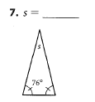 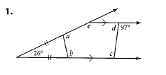

3. Solve and write in the algebra reasons for each step:

a.  b. 