Name:______________________
Sierpinski’s Carpet
Similar to Sierpinski’s triangle, Sierpinski’s carpet is a fractal, but it is made from squares. Complete the questions below, thinking of the steps we did in class for the Sierpinski’s triangle.
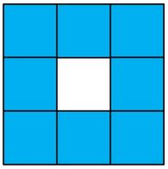

Stage 0 Stage 1
- Complete stage 2 and stage 3 of the Sierpinski carpet.

- Fill in the table using the pictures above.
Stage | Number of Shaded Squares | Number of Squares Not Shaded
0
1
2
3

- Using the table and the pictures above, what expression can be written to describe the number of shaded squares after k stages? How is this similar or different to the Sierpinski triangle?

- If stage 0 had a shaded area of 1 unit², what is the shaded area of stage 1, stage 2, and stage 3? Complete the chart.

Stage | Shaded Area
0
1
2
3

- Imagine you follow this same process up to stage 10. How many shaded squares will there be? What is the area of the shaded region?

Sierpinski’s Carpet Answer Key
- 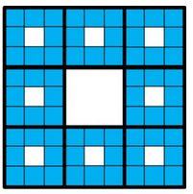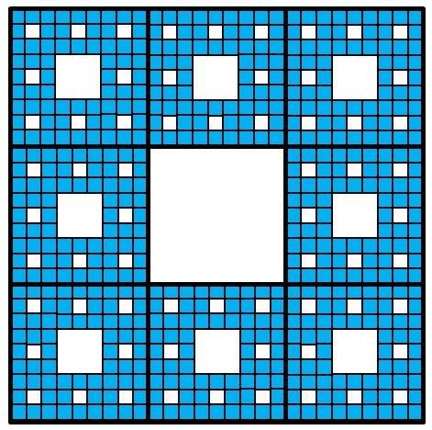
Stage 2 Stage 3

Stage | Number of Shaded Squares | Number of Squares Not Shaded
0 | 1 | 0
1 | 8 | 1
2 | 64 | 9
3 | 512 | 73

- 8^{k} is the expression to find the number of shaded squares at stage k. The expression is similar to the Sierpinski triangle by the base of the expression is the number of shaded shapes in stage 2. It also represents the number of shaded shapes that are added to each subset each time.

Stage | Shaded Area
0 | 1 unit²
1 | 8/9 unit²
2 | 64/81 unit²
3 | 512 /729 unit²

- Number of shaded squares: 8¹⁰ = 1073741824
The area of the shaded region: 8^{n}/9^{n} = 8¹⁰/9¹⁰ = 0.31
https://www.illustrativemathematics.org/content-standards/tasks/1523

