1. Prove that a point P lies on the angle bisector of angle  if and only if the (perpendicular segment) distance from P to BA and the distance from P to AC are equal.

2. Prove that the angle bisectors of triangle  are concurrent.

3. Given triangles, points and segments such *D* and *E* are midpoints of the respective segments in the diagram below, find two pairs of similar triangles, and prove that they are similar.

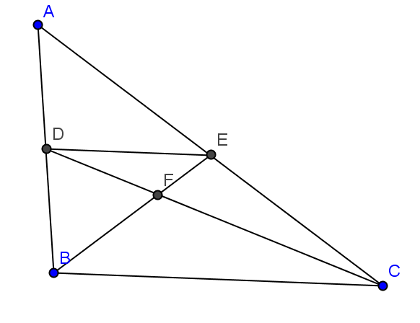

Assigned later:

Starting with an arbitrarily chosen length line segment (whose length you will call 1), show how to construct the lengths:

2, 3, ½ 

***A short list of important theorems:***

***Axiom SAS***  Side Angle Side Congruence: If two sides and the included angle of one triangle are congruent to two sides and the included angle of another triangle, then the triangles are congruent.

**ASA Congruence Theorem:** If two angles and the included side of one triangle are congruent to two angles and the included side of another triangle, then the triangles are congruent.

**Isosceles Triangle theorem**:

1. **Side implies angle:** If two sides of a triangle are congruent (i.e. the triangle is isosceles), then the angles opposite the congruent sides are congruent.
2. **Angle implies side:** If two angles in a triangle are congruent, then the sides opposite the congruent angles are congruent (and hence the triangle is isosceles).

**SSS Congruence Theorem:** If three sides of one triangle are congruent to three sides of another triangle, then the triangles are congruent.

**HL Congruence Theorem:** If in a right triangle the hypotenuse and one leg is congruent to the hypotenuse and a leg of another right triangle, then the triangles are congruent.

**Parallel If Supplementary Theorem:** If two lines are cut by a transversal in such a way that the interior angles on the same side of the transversal are supplementary, then the lines are parallel.

**Parallel lines exist theorem:** Given a line *L* and a point *P* not on the line, there is line containing *P* that is parallel to *L*.

***Parallel Postulate (Axiom)***. If two lines are cut by a transversal (a line that intersects both of the given lines), and two interior angles on the same side of the transversal are in sum less than 180°, then the given lines intersect on that same side of the transversal

**Supplementary if Parallel Theorem:** If two parallel lines are cut by a transversal, then the interior angles on the same side of the transversal are supplementary.

**Vertical angles theorem:** Vertically opposite angles are congruent.

**AIA Theorem:** Given two distinct lines cut by a transversal, the lines are parallel if and only if the alternate interior angles are congruent.

**CA Theorem:** Given two distinct lines cut by a transversal, the lines are parallel if and only if the corresponding angles are congruent.

**AEA Theorem:** Given two distinct lines cut by a transversal, the lines are parallel if and only if the alternate exterior angles are congruent.

**Triangle Angle Sum Theorem:** The sum of the angles in a triangle is 180º.

**Points on perpendicular bisector theorem:** A point is equidistant from the endpoints of a line segment if and only if it lies on the perpendicular bisector of the segment.

**The Pythagorean theorem:** The sum of the squares of the lengths of the legs of a right triangle is equal to the square of the length of the hypotenuse.

Alt: The sum of the areas of the squares constructed on the legs of a right triangle is equal to the area of the square of the length of the hypotenuse.

**Triangle similarity lemma:** Given a triangle  , with segment  such that *A-D-B* and *A-E-C* and  is parallel to  , then  .

**Triangle similarity lemma converse:** Given triangle  with segment  such that *A-D-B* and *A-E-C* and  , then  is parallel to .

**AA similarity:**  If two triangles have in common two congruent angles, then the triangles are simila .

**SAS similarity theorem:** Given triangles  and  such that  and , then 

**SSS similarity theorem:** Given triangles  and  such that  , then .