Equivalent fractions using a visual model. Explain how we know that 18/15 = 6/5.

- I’ve been convinced that we should talk about equivalent fractions also from a scaling model, but that’s a less concrete model, and I want to make sure that you understand the more concrete model first.
- I’m going to show 3 models: line, square and grid paper. Circle/manipulative models are good choices too, but they rarely get as small as fifteenths.
- It’s easier to explain multiplication than division, so I’m going to do this first by starting with 6/5. If it doesn’t take too long, I’ll then go on to show how you could explain it the other way.

Begin by showing what you will use to represent 1whole:
Partition a whole into 5 equal parts, to show the size of 1/5.
Add another 1/5 to the diagram, and use it to show 6/5 (extending to a full second unit is optional)
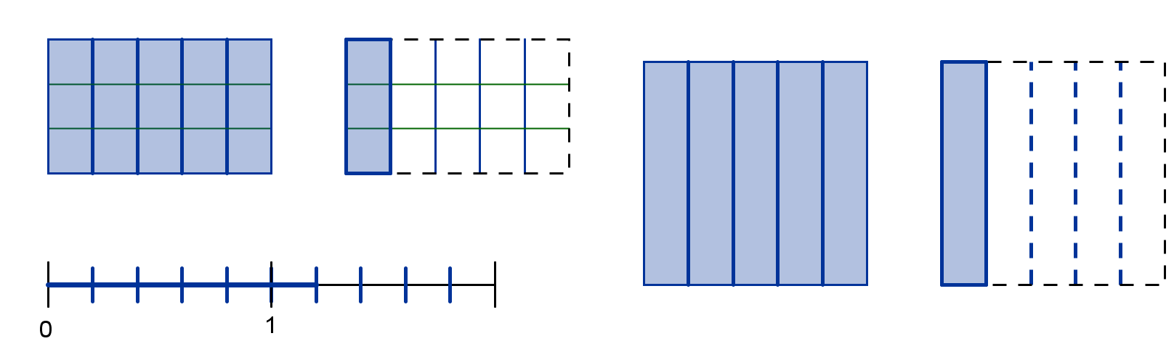
The shaded part shows 6/5 because there are 5 parts in a whole (in the rectangular/square models, these are the 5 columns), and the shaded part has 6 of the 1/5 parts.

Partition each fifth into the same number of equal parts. 5 × 3=15, so if you split each of 5 parts into 3, you will get 15 parts which are fifteenths.

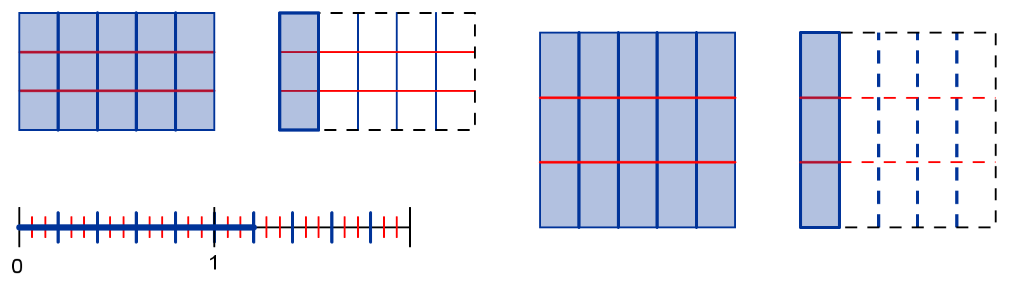
Note, you don’t have to redraw all of the steps—it’s OK to add onto your first diagram so that all I see is the finished version.

- This is the complete visual model.
- This visual model shows that the fractions are equivalent by showing that they are two names for the same amount by regrouping (splitting) within the same picture. The line model also shows that the fractions are two different names for the same point on the number line.

If you look at the whole now with the smaller partitions, you’ll see that the 5 parts in a whole were each split into 3 parts, so there are 3 × 5 = 15 parts in a whole, and each of these small parts are fifteenths.

The shaded area was made of 6 larger 1/5 sized parts, and when each of those 6 were split into 3 smaller parts, that made 3 × 6 = 18 smaller parts in the shaded region.

When we do this, we’re multiplying the numerator and denominator of 6/5 by 3 to get the new name of the fraction.:

- This satisfies: An accompanying numerical strategy should be shown (either multiplying numerator and denominator by the same number of dividing numerator and denominator by the same number).
- It also satisfies: There should be an in-words explanation of how to see the numerical strategy in the visual model (should be explaned in terms of why it is multiplication or why it is division, which goes beyond demonstrating that the numerical answers are the same).

Our shaded region has two names: 6/5 (when we look at the larger pieces) and 18/15 (when we look at the smaller pieces). Both of these names describe the same amount (the size that’s shaded didn’t change), so those fractions are equal.

- This satisfies: There should be an in-words explanation of the equivalence in words (using one of the above reasons)

I’m running out of time here, so I’m not going to explain the other direction in this document.

