**Example of dividing fractions with a partitive example for the problem 9/4 ÷ 2/5:**

***Try to understand this one. I think it works better than the measurement version.***

*The partitive interpretation is tricky, so I’ll start with a whole number version to help it make sense:*

Dividing 6 ÷ 2 can mean that if 6 units of stuff fits evenly into 2 sets, 6 ÷ 2 is the amount in 1 (whole) set.

So 9/4 ÷ 2/5 would mean that if 9/4 units of stuff fits evenly into 2/5 of a set, then 9/4 ÷ 2/5 is the amount in 1 whole set.

* These sentences are a restatement of the problem using a partitive division context

*For a partitive division problem, it is generally best to make a bar diagram that shows the fraction that is the divisor, and label it with the information from the problem.*

2/5 set = 9/4 of a unit

1 whole set = ? of a unit

* As you will see, this model shows why we divide 9/4 by 2 and multiply by 5, so this satisfies: A visual representation of the problem that is robust enough that the calculations can be explained by the visual model alone.

To find how much is in 1 whole set, I first need to know how much is in 1/5 set:

9/4 fits evenly into 2 of these, so to find out how much is in one of these, I need to find half of 9/4 (divide by 2 or multiply by 1/2:



To find out how much is in 1 whole set, I need 5 of these, so I must multiply the amount in 1/5 set by 5:



* This explanation satisfies: An explanation of how to deduce from the visual model that you should divide 9/4 by 2 and multiply it by 5 (in either order)

What we did was:



We found half of 9/4, which multiplied the denominator by 2, and we multiplied by 5, which multiplied the 9 by 5, so this is the same as multiplying 

* An explanation that dividing by 2 and multiplying by 5 is the same as multiplying by 5/2.

*This particular visual model (partitive) has the added bonus that you can see that a whole set is 5/2 of the known amount (think of the two parts as being the whole we compare to, and you’ll see that the unknown amount is 5/2 of it, hence*: 

9/4 of a unit

? of a unit

**Example of dividing fractions with a measurement division example for the problem 8/3 ÷ 2/5:**

*The measurement interpretation is easier (than partitive). Making it fit “invert and multiply” is harder (than partitive) at the end*

9/4 ÷ 2/5 means that if you make sets of size 2/5 of a unit of stuff out of a total amount of 9/4 of a unit of stuff, then there are 9/4 ÷ 2/5 sets of stuff.

* This is: A restatement of the problem using a measurement division context

*With measurement division, you need to show the total (dividend) amount in some way. I usually use a number line for this, but we’re going to need a common denominator so I’ll try a rectangle version on the next page too.*

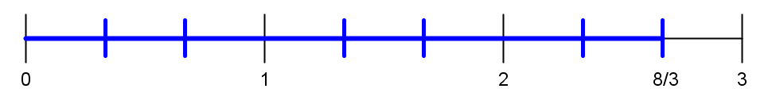

I’m going to need to show groups of 2/5 that make up an amount of 8/3, so here I’ve got 8/3 on this number line, and to show 2/5, I’m going to have to find a common denominator so I can figure out just how the two different fractions fit together on the number line.

15 is a multiple of 5 and a multiple of 3, so I’m going to rename the fractions in 15ths:

 and . It’s also going to help me to know that 

I’m going to draw in fifteenths on the number line and I’m going to put a darker line at every 3rd line to show where the fifths are:

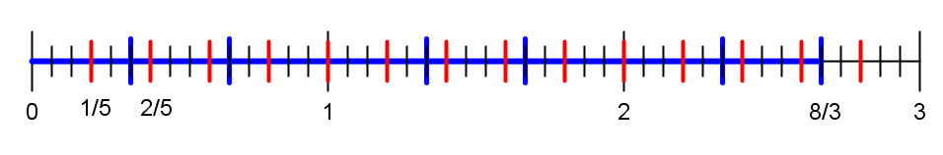

One thing that I could do is to just count up how many sets of 2/5 there are (6), and figure out how many more little fifteenth parts there are left over (4), and use the number of fifteenths in a set (6) to write the leftover amount as 4/6 of a set, and that would get me the answer 

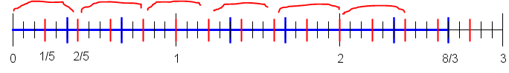

* This picture is not only good enough to explain the calculations, it’s detailed enough that you can count the answer. It satisfies: A visual representation of the problem that is robust enough that the calculations can be explained by the visual model alone.

*OK, now for the tricky bit:*

Another way to find out how many 2/5’s are in 8/3 is to first figure out how many fifths there are in 8/3. We can use multiplication for this because there are 5 fifths in 1, and 2×5 fifths in 2, and there are  fifths in 8/3.





If you know how many fifths there are, you can make groups of 2 out of those to make sets of 2/5. That means dividing  which means you have half as many sets of 2/5 as you have sets of 1/5:











* This is a pretty good way of doing: An explanation of how to deduce from the visual model that you should divide 7/4 by 2 and multiply it by 3 (in either order). *Notice that when it is a partitive model, it makes the most sense to first divide by the numerator and then multiply by the denominator, and in the measurement model it makes the most sense to first multiply by the denominator and then divide by the numerator.*

When we multiply be 5 and then divide by 2, we end up multiplying the numerator of 8/3 by 5 and multiplying the denominator by 2, which is the same as what happens if we multiply by 5/2.



* This does: An explanation that dividing by 2 and multiplying by 3 is the same as multiplying by 3/2.

*The last part of this isn’t as slick as it was with the partitive version, but as you can see (I hope) it’s possible to make the connection. This model actually connects better with the common denominator algorithm for fraction division (this was in the textbook readings), but the standard algorithm is the multiply by the inverse algorithm, so that’s the goal of this exercise.*

You want some more pictures? Here are some!

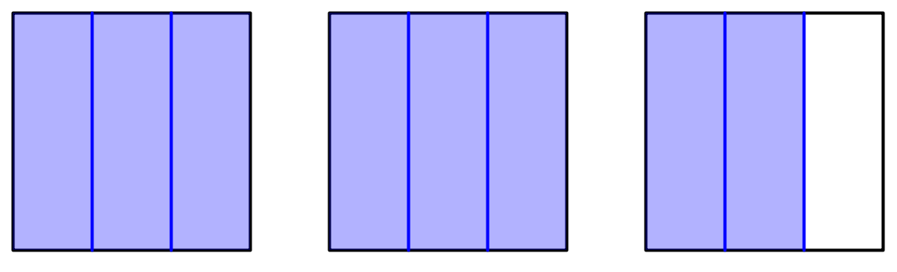

8/3 as squares

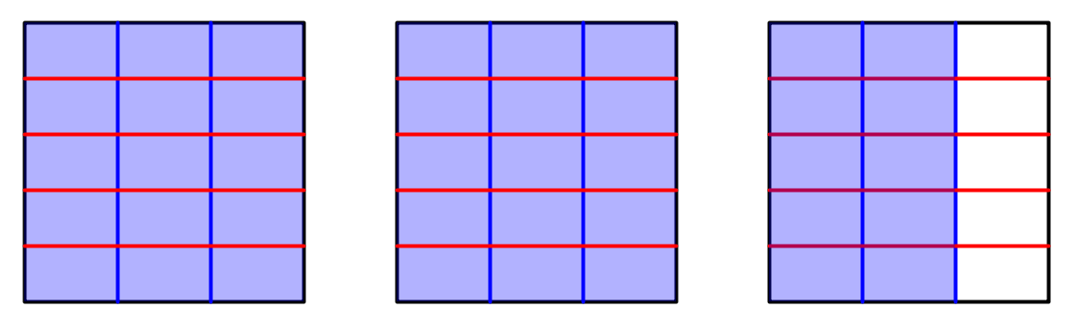



And here we have fifteenths.





We can show fifths and sets of 2/5 this way

Or (I kinda like this better maybe?)



5/5 5/5 2/3 of 5/5



8/3 of 5/5

8/3 of 5 fifths.