Adding fractions Example 2/3 + 4/5

*Comments in italics are extra explanation that are not necessary for the assignment*.

*A fundamental principle of addition is that it can only be applied to things that are described using the same units of measurement. You can add apples to oranges if they are measured as servings of fruit, but you can’t add cups of water to gallons of water until you fix the amounts so you’re measuring in the same unit. Any time we write an addition sentence we are implicitly saying that the numbers represent amounts of the same unit*

*Step 1: choose a unit (which will stay fixed for this problem). I will show the process for a length unit, a square unit and a rectangle on grid paper.*

*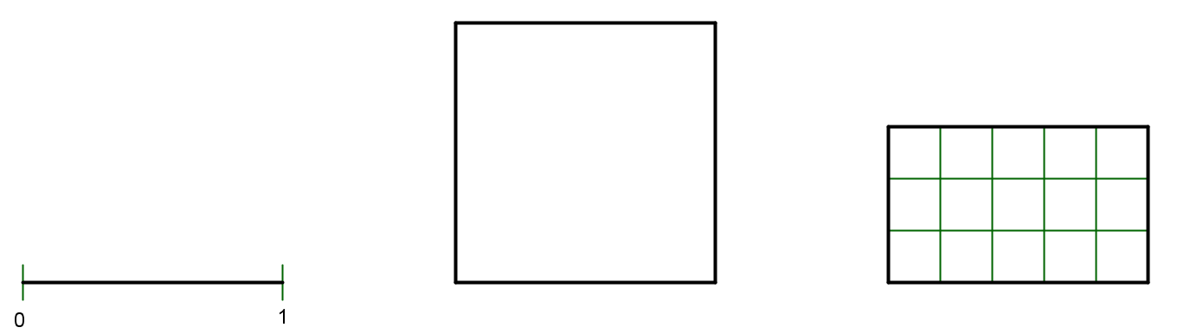*

*You are not required to show this step separately*

*Step 2: show both 2/3 and 4/5 as fractions of the chosen unit.* Split one copy of the whole unit into thirds (3 equal parts) (using horizontal lines for squares and rectangles), and shade 2 or label of them, and split another copy of the whole unit into fifths (5 equal parts) (using vertical lines) and shade or label 4 of them.

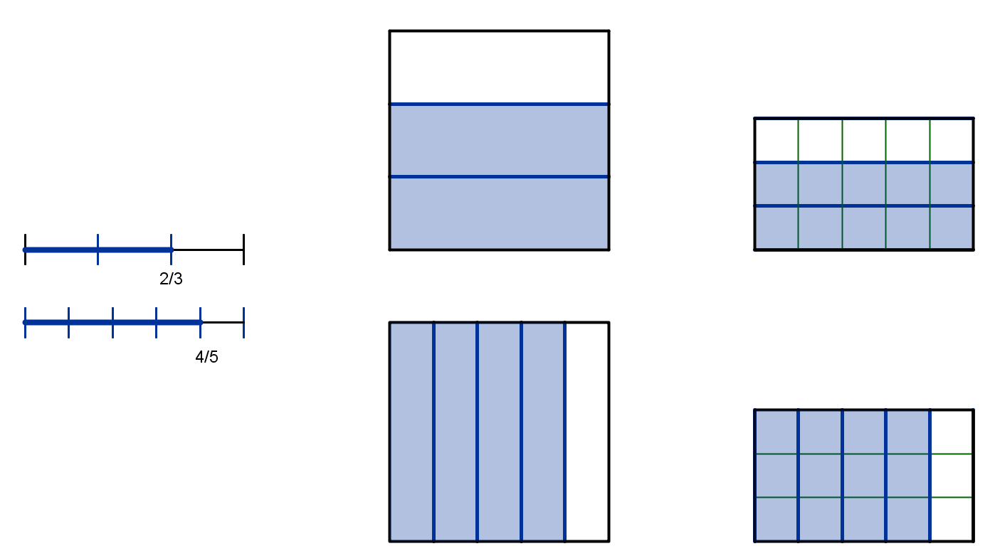

* This picture and explanation satisfies: Use a visual model, where both fractions are represented in terms of the same sized whole.

Step 3: Partition each 1/3 into 5 pieces (using vertical lines), and each 1/5 into 3 equal pieces (using horizontal lines). This makes the same size of pieces in both fraction pictures. *if you are using a square or rectangle, you should specify the direction of the step 3 partition, and if you are using a number line model, you should make the part 3 subdivisions slightly smaller or in a different color.*

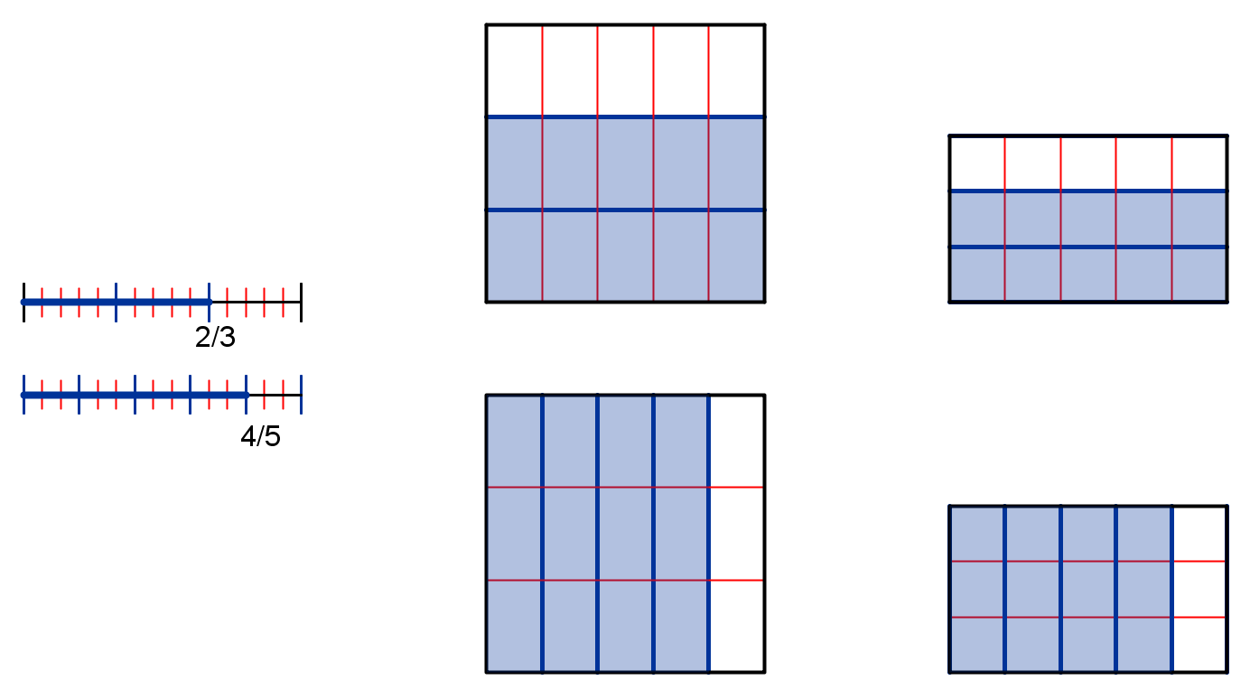

*Note: you may draw these subdivisions over the top of your step 2 picture, but you should try to make the process clear in your in-words description.*

* This satisfies: Show on the model and explain in words the process of finding equivalent fractions with the same denominator.

In the first diagram, each of the 2 parts in the shaded 2/3 are split into 5 parts each, so there are 2 × 5 small parts now.

Each of the 3 parts in whole in are split into 5 parts each, so there are 3× 5 small parts in a whole, and each is size 1/15.

This means 10/15 is equivalent to (is the same number/size as) 2/3: 

In the second diagram, each of the 4 parts shaded in 4/5 are split into 3 parts each, so there are 4 × 3 small parts now.

Each of the 5 parts in whole in are split into 3 parts each, so there are 5 × 3 small parts in a whole, and each is size 1/15.

This means 12/15 is equivalent to (is the same number/size as) 4/5. 

* This satisfies: Show in numbers the process of finding equivalent fractions, and use the visual model to explain the numerical process (how can you see the products in the diagram or in the process of creating the diagram)

Added together, there are 10+12=22, each of which is 1/15: 

* Show with numbers the process of adding together the fractions with the same denominator. Explain in words why you add the numerators but the denominators stay the same.

15/15=1, and 22 is 7 more than 15, so  *This step is optional*